Newsletter
26th November 2020
Dear Parents and Carers,
It has been another great few weeks here at Durham Lane Primary School. The children have settled back into school after half term well and are enjoying learning about a whole host of topics such as Diwali, Vikings and the Great Fire of London. I have been particularly impressed with the children’s attitudes towards helping others; what kind children you have!

Cause for Christmas Hamper Campaign
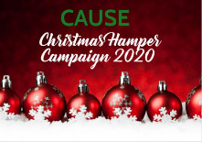
Thank you so much for your generosity in supporting our local families. This is such a humbling cause and I am so grateful that you are supporting it. Could we please ask that if you are bringing in any donations, they are sent in by Tuesday 8th December 2020.

Christmas Raffle
Covid-19 is certainly not going to stop the fun at Durham Lane this year. We are planning an array of events such as: the Christmas raffle; decorating the Christmas tree and Christmas Craft Bags. Tickets for the raffle will go on sale on 30.11.20. The prizes this year are incredible, so watch this space.

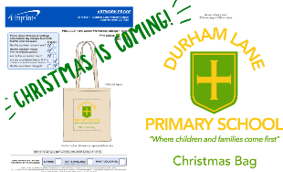
Christmas Bag
Due to Covid-19, we are unable to do a Christmas Fayre this year. However, we have created our very own Christmas Fayre in a bag. These will go on sale very soon!

Mayor’s Christmas Carol Concert
This year, the Mayor’s Christmas Carol Concert will be held virtually. Our very talented, Year 6 children will be performing ‘One Night, One Moment’ taken from the film, ‘The Nativity’. We are hoping to be able to share this via our school website. So again, watch this space.

Music
Having read our pupil surveys, it was apparent that the children were missing choir and music in our school. Therefore, we have employed a music specialist (Mrs Bridie Bailey) through Egglescliffe Comprehensive School who will be working with all pupils at some point during the year.
Christmas Cards
We are more than happy to facilitate the giving out of Christmas cards. However, we are only able to give out cards to friends who are in the same class bubble and there are a few changes this year, in light of Covid-19 guidance. We will only accept Christmas cards on a Monday. They will then be put into quarantine and we will send them to the receiving children on a Friday.
Christmas Parties
This year, because we cannot mix our class bubbles, we cannot unfortunately hold the usual annual Christmas Disco. However, each class will be having a small party in their classroom during the last week of term (more details to follow).

Christmas Performance
Unfortunately, we are unable to do our usual Christmas performances this year.
Instead, our Early Years pupils will be performing ‘All About a Baby’ which will be videoed and shared on the school website.
Children in Years 1 -6 will be performing their own part of our show called ‘The Stars are Coming Out for Christmas’. We will also share this video on our school website page and we thought it would be lovely idea if as many of you as possible, could join us once it goes live.
More details about both of these performances will be sent out via your child’s teacher.
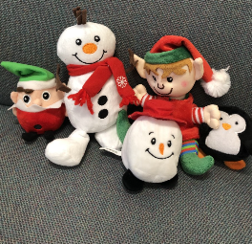
Butterwick Flumpets
This year, in order to support the Butterwick Hospice, we will be selling Christmas ‘Flumpets’ at the cost of £1.50 each. If you wish to purchase one, please either send the money in an envelope with your child or purchase one through Schoolcomms.

Amberley Way Park
New Covid-19 legislation (4th November) states that families are only able to meet up with one other person outside of school. Could I please remind you of this when accessing the park before or after school.

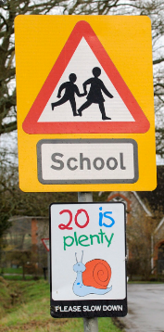
Parking and Road Safety
I have been made aware of a few near misses involving children, on Amberley Way. I have been in contact with Stockton Traffic Wardens who will be spending some time outside of school over the coming months. Please, please, please can you be very careful when driving on Amberley Way. If you can, why not park over at the Orchard Shops and walk to school? Also, can I please request you follow the one way advice; it really helps with the traffic flow and keeping our children safe.

Schoolcomms
Schoolcomms will soon be our online communication tool and will go live on Friday 27th November. To download the app, search school gateway in your app store. A letter regarding how to access this was sent out on 25.11.20. If you have any problems, please contact caroline.ennion@sbcschools.org.uk in our school office.

Marshalls
Simon from Marshalls visited our school site this week and has offered to help us develop our Early Years Outdoor Provision. We are extremely grateful that Marshalls will be providing us with materials and labour for free and we look forward to seeing what magic they can work on our Early Years’ playground!

Flu vaccination
If you have registered for your child to receive a flu vaccination, the nurses will be in school to administer this on 2nd December.

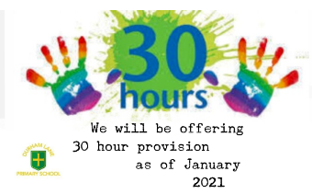
Nursery 30 hour provision
The governors have now approved the proposal to offer a 30 hour provision for our Nursery children. If any parents would be interested in this offer, could you either phone me or email me on helen.gregory@sbcschools.org.uk to discuss your possible requirements.

Parent Consultation evenings
Thank you so much for everyone who attended the Parents’ Consultation evenings. (97% of our parents). It is so important for school and home to work together to ensure your child reaches their full potential. We are still operating an open-door policy so, if you need to speak to a teacher, we can arrange a telephone appointment. Please speak to Caroline Ennion in the school office to arrange.

Covid-19 testing
If your child/family member is waiting for a Covid-19 test result, could you please email me the result, even if it is over the weekend. My email address is helen.gregory@sbcschools.org.uk

This will help me plan and inform Public Health England. If your child is currently living with a household member or sibling who is waiting for a test result, once that result has been confirmed, please let me know, in accordance with the up to date guidelines which can be found on the school website.

Thank you
I would just like to take this opportunity to thank you for welcoming me into your school family; I am so lucky working with such a wonderful school

Kind regards,

Mrs H Gregory

helen.gregory@sbcschools.org.uk

