Newsletter
6th November 2020
Dear Parents and Carers,
It has been so lovely to see all the children returning to school. They have bounced back to school with such gorgeous smiley and happy faces. We were so relieved that the children could continue to attend school during this current lockdown period, however we are having to make a few changes in light of the new government guidance.

After school clubs
Unfortunately, the Year 5 and Year 6 after school sports club, will need to be put on hold until after the 2nd December. This is due to new lock down restrictions. After school clubs can continue during lockdown, however this can only be for child care reasons.

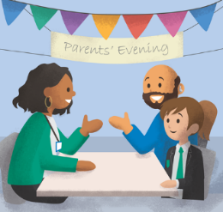
Parent Consultation evenings
Staff will also be hosting our very first ‘Zoom’ parent consultations on Monday 9th and 16th November. I have been in close contact with our broadband provider and I requested an upgrade weeks ago. However, this has not come in time for our parents evenings, So fingers crossed it will all go well!

Sponsored fun run
We are all in awe with how much the children have raised for the sponsored fun run to France. We have just hit the £3,000 mark. Our School Council members had a meeting this week and would like to spend the money raised on more iPads for school, playground equipment and books for classrooms. Purchases have already been made! Thank you again for your support ; you are just incredible!

Nursery 30 hour provision
The governors have now approved the proposal to offer a 30 hour provision for our Nursery children. If any parents would be interested in this offer, could you either phone me or email me on helen.gregory@sbcschools.org.uk to discuss your possible requirements.

Amberley Way Park
New Covid-19 legislation (4th November) states that families are only able to meet up with one other person outside of school. Could I please remind you of this when accessing the park before or after school.

Personal information documents
Thank you so much to everyone who has completed their child’s personal information document. We have sent this document out to support with our new school communication system- School Comms. Once all information has been received, we will be sending out information on how to download the School Comms app. Once we have this set up, we will be moving away from paper communication to emailing and text messaging.

Fun, Food, Friday for Pudsey Day
On Friday 13th November children can enjoy Fun, Food, Friday. The kitchen will be serving:
Hotdogs
Burgers
Pudsey cakes and biscuits
Cost is £2.05 please send your money in before Friday 13th November.

Children in Need
Although the way we raise money may be different this year, we are still keen to have a fun, money-raising day on Friday November 13th. The School Councillors have decided that we will have mis-matched/bright clothes and crazy hair on this day, which we are all looking forward to! Donations of at least £1 to dress up will be gratefully received and, should children/parents wish to donate extra money, there will be buckets at the school entrance. Your children will also be decorating a cake as part of the fun activities on the day and these will cost 30p, which should be sent in with your child on the day. Please donate as much as you can as, this year, we will be giving the money directly to The Little Sprouts Well-being Charity which is a local charity who donate food hampers to families who are struggling to provide food for their children; I’m sure you will agree that this is a very worthy cause, especially in these difficult times.

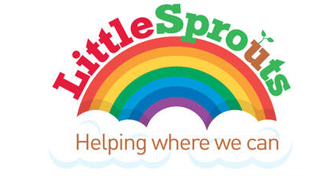

Welcome
We would like to welcome Mrs J Wheatley to our staff team. Mrs Wheatley will be predominately working in Year 3 and Year 5 every morning. She will also be offering playground game activities during lunch time to support with physical health and well-being during lunch time.

Covid-19 testing
If your child/family member is waiting for a Covid-19 test result, could you please email me the result, even if it is over the weekend. My email address is helen.gregory@sbcschools.org.uk
This will help me plan and inform Public Health England. If your child is currently living with a household member or sibling who is waiting for a test result, once that result has been confirmed, please let me know, in accordance with the up to date guidelines which can be found on the school website.

Working from home
Unfortunately, a member of my support bubble has tested positive for Covid-19. Therefore, I need to self-isolate and work from home. If you need to make contact, either email me or contact Caroline Ennion in the school office to make a telephone appointment.

Thank you
I would just like to take this opportunity to thank you for welcoming me into your school family; I am so lucky working with such a wonderful school

Kind regards,

Mrs H Gregory

helen.gregory@sbcschools.org.uk

