**Lunch**

All Key Stage One children are entitled to a free school meal, irrespective of household income. Each term a letter will be sent home to ask whether your child would like a school dinner, will be

bringing a packed lunch or whether they would like to do a bit of both. If your child would like to alternate between school dinner and packed lunch, you need to complete a school dinner envelope. We will be putting some of these in the children’s school bags for you. Please tick to let the kitchen staff know which days your child would like a school dinner. These envelopes need to be handed in on the Monday of each week so the kitchen staff can order the right amount of food.

**Uniform**

Please can you make sure all your child’s uniform, shoes and coats are clearly labelled with their name.

**End of school day**

Year 2 children are collected at 3.15pm outside the classroom door on the playground. If your child is being collected by somebody who does not usually pick them up, please can you let the class teacher know on the morning, leave a message with the adult on the playground in the morning or phone the school office.

**Homework & Spellings**

Every Thursday, your child needs to bring in their yellow spelling book. They will be tested on their spellings on Thursday and new spellings will be given out on Friday. Help your child to practise their weekly spellings using the ‘Look, Say, Cover, Write, Check’ Method:

‘*Look at the word, say the word, cover it up, write the word, check the word’*

Your child’s homework will be handed out on a weekly basis on a Friday and needs to be back in the following Thursday. Help your child with their homework if needed. Please don’t do it for them, but ask questions about it to ensure understanding. If you ever have any concerns, please feel free to contact your child’s teacher. A timetable will be sent out giving you the dates to help make it a little bit easier.

**Welcome to Year 2**

Your child’s class teacher is **Mrs Jessop** and **Mrs Spruce** is your child’s teaching assistant.

**Topics**

In Year One this year, some of the topics that will be studied are:

* Far, Far Away
* London’s Burning
* Take One Picture

**What your child needs each day**

Your child will be receiving reading books weekly instead of daily at the moment. If you could bring your child’s reading wallet to school on a Thursday, we will clean the books and put between 3-5 new reading books for your child to read over the next week. Please record how they have read in their reading record.

|  |  |
| --- | --- |
| Monday | Dinner envelope if required, PE* |
| Tuesday |  |
| Wednesday |  |
| Thursday | Reading wallet, spelling book & homework folder, PE* |
| Friday |  |

*\* PE: your child just needs to bring PE shoes in a labelled bag which will be kept at school. They do not need a PE kit at the moment. Jewellery, watches, metal hairclips and earrings must be removed before lessons.*

Please make sure your child brings in a water bottle so they can have a drink throughout the day. They also need a wipeable pencil case including: rubber, pencil/wax crayons and pencil sharpener; this will also be kept at school.

**School Bags**

We need to keep our corridors as uncluttered as possible so please do not send backpacks and large bags to school. Your child can bring their small Durham Lane bookbag to school every day. If you do not have one of these, we sell them for £4. You can send the money in an envelope to your class teacher and they will give one to your child at the end of the school day.

**Snack**

Key Stage One children are part of the Government free fruit scheme, however it is currently suspended. If your child would like to bring their own snack, they can bring their own piece of fruit or veg to eat at morning playtime. Just a reminder to make sure small fruit such as grapes and tomatoes are cut in half to prevent choking.

* Healthy Me
* Author Study
* Secret Garden

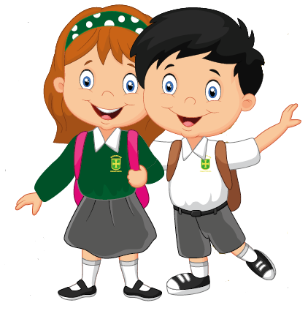

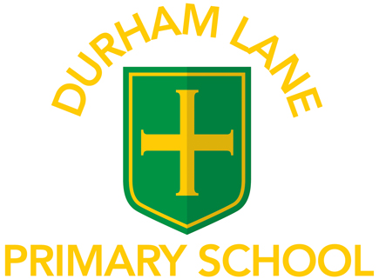

# Welcome to

A Guide for Parents

2020/2021

**Reading**

Reading is a key focus in Key Stage 1. Your child’s reading skills are developed through a combination of phonics lessons, weekly guided reading and independent reading. Your child has a set of reading books in their wallet to read at home over the course of a week. It is extremely beneficial to listen to your child read as often as possible. Question your child about what they have read to check their understanding. We will collect reading books in every Thursday and hand out a new set of books on a Friday. Please record in their reading record so we know which books they have read.

**Any problems or concerns**

If you have any problems or concerns, we operate an ‘open door’ policy. This is very difficult at the moment, but please do not hesitate to ask if you would like to talk to your child’s class teacher. We will be checking the children’s reading records at least once a week so please feel free to write a message in there or there is an adult on the playground taking messages which will be passed back to your child’s teacher.

Your child’s class teacher is always your first point of contact. If you are dissatisfied, the first person to contact is Miss Barrett, the Deputy Head Teacher. The next person to contact is Mrs Gregory, our Head Teacher.

We hope to solve problems promptly and with care and are always happy to discuss your concerns.

We appreciate your continued support.

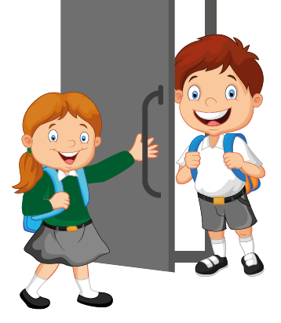

Year 2

Key Stage One