Newsletter
17th December 2020
Dear Parents and Carers,
As we come to the end of our first term, I would like to thank you all for what I would describe as a wonderful, yet very challenging term. The children have been a real credit you all and have adapted so well to the changes, due to Covid-19. I believe we are one of the very few schools in Stockton who have not had to close a bubble down. My sincere thanks goes out to you all for ensuring we all do our bit and follow government guidance.

Track and Trace
Over the holidays, track and trace have asked schools to remain on call until Christmas Eve. Could you please email me on helen.gregory@sbcschools.org.uk to keep me informed if anyone in the family has received a positive Covid-19 result. This will ensure I can contact all close contacts who may then need to self-isolate. Can I also remind you, that the self-isolation period has now changed from 14 days to 10 days.

Christmas Celebrations
The children have had the opportunity to celebrate Christmas in all kinds of ways. They have enjoyed parties, carol concerts, Christmas Dinner Day, performances and craft time. The children have loved having opportunities to spend time with their class friends; there have been lots of smiles and laughter in school over this period which has been so lovely to see.

Cause for Christmas Hamper Campaign
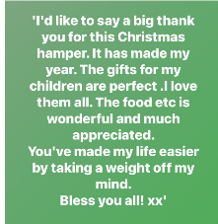
Thank you so much for your generosity in supporting our local families with the ‘Cause for Christmas Hamper Campaign’. This comment was left on their Facebook page from a family who had received a hamper. When we all come together, we can make such a difference.

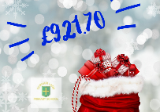
Christmas Raffle
Miss Hugill and Miss Drew have worked really hard at organising the school Christmas raffle and name the bear. I can now reveal the name of the bear is Luigi
The lucky winner was George in Year 4.
You have raised £921.70 for the school funds and the children have already been writing a wish list. They would like:
- Books for home reading
- Books for the classroom
- Playground equipment
- Improvements on the playground
- New Camcorder
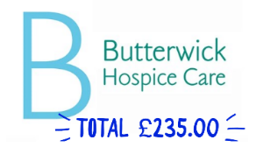

Butterwick Flumpets
This year, the children have raised a staggering £235.00 for Butterwick Hospice, from the sale of ‘Flumpets’.

Christmas Performance
Our Christmas performances have been slightly different this year. Both performances can be found on our new website www.durhamlane.org.uk and they are listed under the Video Gallery page. I would like to take this opportunity to say well done to all the children; the performances are just incredible and a special thank you to Mr Beane who is a very talented director and editor.
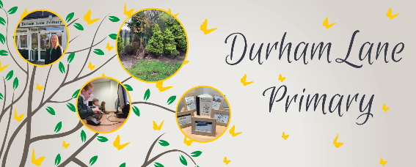

Durham Lane Website
This term, we have been working really hard on designing and creating a new website. We are hoping that this design is much easier for you all to use. If you have any feedback on the design or ease of use, we would really like your opinions.

We have also attached the link for Parent view which is an online questionnaire which helps us to improve. We would love your feedback. You can find the link on the parents’ section of our new website.

Schoolcomms
This will be your last paper copy of the school Newsletter as, from January 2021, all communication will be sent via Schoolcomms. To download the app, search school gateway in your app store. If you have any problems, please contact caroline.ennion@sbcschools.org.uk in our school office. All afterschool club bookings will be placed on here. We will be accepting lunch money payments on Schoolcomms in the New Year, so watch this space!

Message from the Chair of Governors

We would just like to take this opportunity to thank all of our families for the phenomenal support they have shown school this year. It hasn’t been an easy year for anyone, but we have all pulled together and achieved some amazing results. We are very proud of how all the children have coped and how happy and productive they are in school. They truly are a credit to you all. We would also like to thank all our hardworking team at Durham Lane; the staff have gone above and beyond this year and we couldn’t have achieved so much without their dedication. Thank you to my fellow governors that are often called upon at crazy times to support school; I am extremely grateful to have such wonderful support. We hope you all have a wonderful Christmas filled with joy and can’t wait to see you back for what is set to be an exciting 2021!

Clair Robinson

Merry Christmas
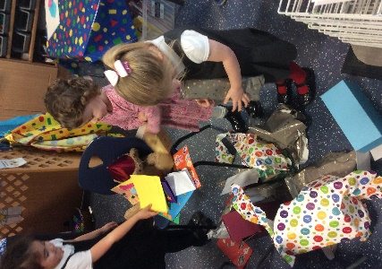
Finally, I have had such a wonderful first term here at Durham Lane. My thanks go out to all of you for welcoming me into your family. I would like to take this opportunity to give a special thanks to the staff; they really are an incredible team to work with and have your children’s best interest in everything they do.

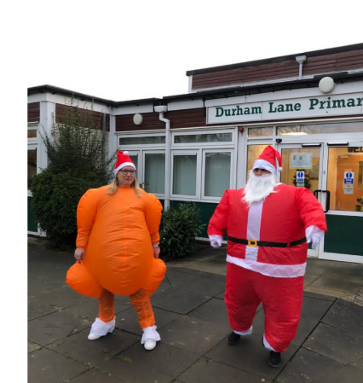
Merry Christmas everyone! I hope you have a wonderful festive period with you family. Take care, stay safe and we will see you all on Monday 4th January 2021.

Merry Christmas,

Mrs H Gregory

helen.gregory@sbcschools.org.uk

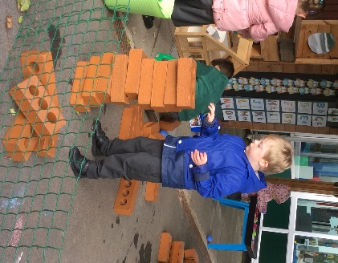
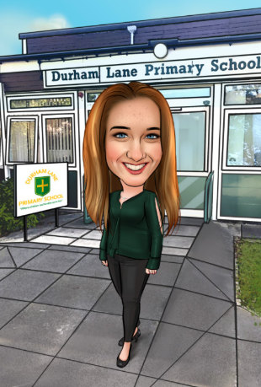

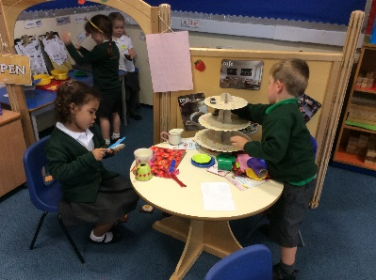

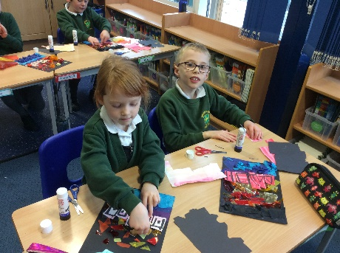
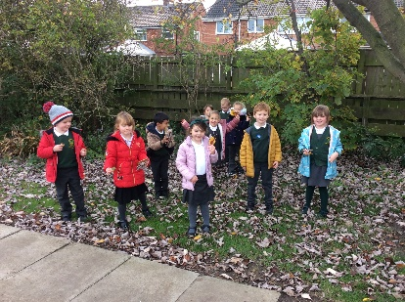

Autumn Term Memories

