Head Teacher – Mrs Helen Gregory
Amberley Way, Eaglescliffe
Stockton on Tees
TS16 0NG
Tel: 01642 780742

Email: durhamlane@sbcschools.org.uk
Website: www.durhamlane.org.uk
7th January 2021
Dear Parents and Carers,

National lockdown: Stay at Home

Following on from the Government’s announcement on the 4th January that the nation is to go into full lockdown to reduce the transmission of the new Covid-19 strain with the advice ‘Stay at Home’, I am writing to keep you up to date with the current numbers of children we have attending Durham Lane School. Currently, 45% of our school community is attending school (83/189 on roll). All children who are attending school are either categorised as the child of a key worker or a vulnerable child.
The government have not stated how small class bubbles should be during this current lockdown. However, during the last lockdown in March 2020, schools had guidance that bubbles should have no more than fifteen children in them. Due to the numbers of children currently attending school, some bubbles are bigger than the first lockdown guidance. I am making you aware of this as some classes will have over seventeen children in them.
As you are aware, the new strain of Covid-19 is up to 70% more transmissible than previously. As a school, we would like to protect our children, families and staff. We urge you therefore, to consider whether sending your child to school at this present moment in time is the best course of action. We completely understand that some parents have no option other than to send their child into school as many of you are critical workers. We are also not trying to dissuade you from whichever decision you have made, but are simply asking you to think about if you have any other options other than sending your child in to school. We fully appreciate how difficult home-schooling can be, especially for the younger children, but we also need to protect our community.
As a school, we have spent the autumn term preparing for the possibility of switching to remote learning. I can confirm that all children from Year 1 – Year 6 will be receiving daily teaching via zoom, with additional calls on some afternoons. This will ensure that your child will be fully informed of the expectations for the day with regards to their learning as well as direct teaching from their class teacher. All learning is on the Seesaw platform and teachers will be giving constant feedback to your child. Children in the Early Years, will have pre-recorded direct teaching and, again, will have learning set via the Seesaw platform.
I would like to thank you again for your continued support during these unprecedented times. If you wish to contact me with regards to the content in this letter, please do not hesitate to do so.

Yours Sincerely
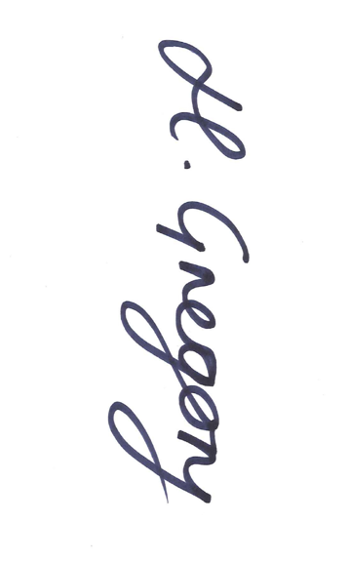
Helen Gregory

