Newsletter
25th March 2021

Dear Parents and Carers,
What an incredible few weeks we have had since we have all returned back to school together. I have been so impressed with how every child has returned to school and has settled back into school life.

Comic Relief
The children had a wonderful day, on Friday 19th March, supporting comic relief. This year, the children have raised a staggering £569.41. Thank you so much for your continued generosity and support.

Parent Consultation evenings – Dates for your diary
Staff will be hosting parent consultations on Monday 24th and Wednesday 26th May 2021.
These will be via zoom and you will receive information on how to book your appointment via parent mail.

Breakfast Club and After School Club
Thank you to everyone who has shown an interest in our ‘After School Club’. If you wish to book your child into one of our clubs, please book via Schoolcomms.
These are the activities set for the next half term:
- Monday – Arts and Crafts (N – Y6)
- Tuesday – Technology (supported by Miss Drew N-Y 6)
- Wednesday – Cookery (supported by Mrs Williams N- Y6)
- Wednesday – Dance Fuzion (Y3 – Y6)
- Thursday – Lego and board games (N-Y6)
- Friday – Sports (N- Y6)

If you wish to book your child into club, the costs are:
Breakfast - £4.50 plus 50p for breakfast
After school 3.15pm – 4.30pm =£5.00
After school 4.30pm – 5.50pm =£5.00
(snack provided)
Total from 3.15pm – 5.50pm = £10.00

Yr 3- Yr 6 Dance Fuzion Wednesday After School club
The children from Year 1 – Year 6 will have the opportunity, over the coming terms, to be taught by Mrs Barnes, a professional dance teacher, on Wednesday afternoons. She will also be offering an afterschool club for children from Year 3 – Year 6. The cost will be £5.00 – there will be no snack with this club.

Year 5–Thursday Multi Sports with Mr Sheahan
The Year 5 multi sports club will restart again on April 12th after school. Can I just remind you that if you wish to book a place, you must do this via Schoolcomms. Note this club is free for the Year 5s for this term only.

Professional Development Days

PD days for this academic Year 2020-21:
- 7th June 2021
- 19th July 2021
- 20th July 2021
PD days for academic year 2021-22:
- 1st and 2nd September 2021
- 1st November 2021
- 6th June 2022
- 21st July 2022

Easter ‘Eggstravaganza’ Raffle
Thank you to everyone who purchased raffle tickets for our Easter ‘Eggstravaganza’. We have raised just over £612.00. This will go towards our Summer DIY SOS summer project. I would really like to thank you for your continued support. Previous funding raising, such as ‘Run to France’ and the ‘Christmas Raffle’, has enabled us to go from 23 ipads in school to 70 ipads. This is an incredible achievement and I am really grateful to everyone who supported us with this.

Butterwick Flumpets
This Easter, from the sale of the Butterwick Flumpets, we have raised £172.50. Thank you and well done!
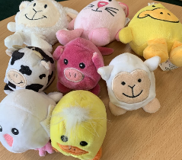

Outdoor Trim Trail
Over the next few weeks, your funding raising will also go towards repairing the trim trail on the playground. We have recently received a quote of £1,200 to ensure it is safe to use again. Thank you so much for supporting us with our fund raising; we really appreciate all your help.

Dinner money
As of 12th April, all dinner money and bookings for lunch (even those who don’t pay for their dinners) will move over to the Schoolcomms system. Lunches will need to booked and paid for on the Schoolcomms app. If you have any questions about our Schoolcomms platform, please don’t hesitate to contact Caroline, who will be more than happy to help.

Eggcellent Eggs!

Congratulations to all of our winners this year who took part in the Egg Decorating completion!

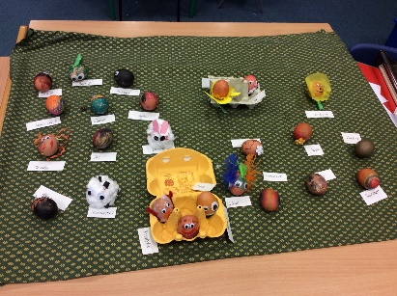

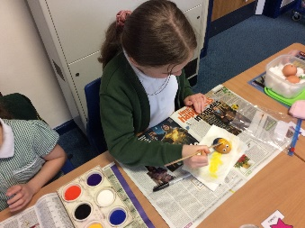

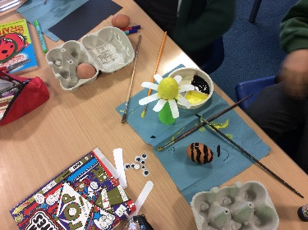

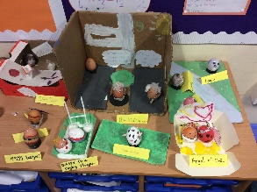

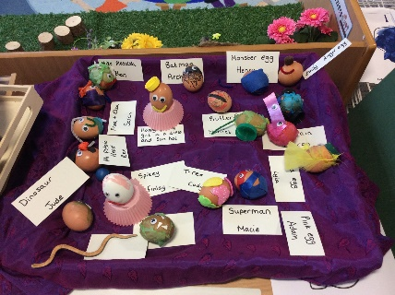

Covid-19 testing
If your child/family member is waiting for a Covid-19 test result, could you please email me the result, even if it is over the weekend. My email address is helen.gregory@sbcschools.org.uk
This will help me plan and inform Public Health England. If your child is currently living with a household member or sibling who is waiting for a test result, once that result has been confirmed, please let me know, in accordance with the up to date guidelines which can be found on the school website. I will be on call for track and trace purposes until Thursday 1st April. Please don’t hesitate to contact me over this time, so I can inform families who may have had immediate contact with someone who has tested positive.

Happy Easter
Finally, I would just like wish you all a Happy Easter!

Kind regards,

Mrs H Gregory

helen.gregory@sbcschools.org.uk
