

**Newsletter**

**7th May 2021**

**Dear Parents and Carers,**

It is lovely to see how our little community school is slowly coming back to life after lockdown. It has been so nice to see the children and staff spending quality time together and I have been really impressed to see how the children have adapted and dealt with so many challenges over the last year and how quickly they have settled back into the school rules and routines.

**Sport Enrichment**

As things continue to return back to ‘normal’, we’re delighted to be working with the following individuals and companies to provide sporting opportunities for our children:

Little Movers Dance (Nursery and Reception) ✅

DF Coaching Lunchtime Games Club (Y3,4,6)✅

Mr Sheahan PE (Reception, Y1,2,4,5,6)✅

Mr Sheahan’s Sports Club (Y5) ✅

Dance Fusion PE (Y3&4)✅

Dance Fusion Club (KS2)✅

Anne Clayton Tennis (Y3&4)✅





**Parent Consultation evenings**

Staff will be hosting parent consultations on **Monday 24th and Wednesday 26th May 2021**.

Thank you to everyone who has already booked their appointment via our Parent Mail App. If you have any problems booking an appointment, please contact Caroline in the school office who will be more than happy to help you. Your ‘Zoom link’ for your appointment will be sent out via the Schoolcomms on the morning of your appointment.

**PD days for this academic Year**

* 7th June 2021
* 19th July 2021
* 20th July 2021

**PD days for academic year 2021-22**

* 2nd and 3rd September 2021
* 1st November 2021
* 6th June 2022
* 21st July 2022

Because of an additional bank holiday, which has been granted by Government in order to celebrate the Queen’s Platinum Jubilee, it has been necessary to amend the academic calendar for 2021/2022.  The new calendar means that staff will return to school on 2nd September 2021.

This means that we will be having PD Days on the 2nd and 3rd September and all the children will return to school on the **6th September 2021**.

**Breakfast Club and After School Club**

 Our Breakfast Club and After School Club has seen some radical changes over the last few weeks. The uptake of the club has really improved and I would sincerely like to **thank you** so much for supporting our club. The children are clearly loving the changes and are extremely complimentary about the activities we are offering. Some activity clubs are regularly full, therefore please get booking early – we wouldn’t want to disappoint anyone! However, we will **always** have space for your child if you need child care in after school club.

After Half Term we will be offering the following activity clubs:

Monday – Arts and Craft

DF coaching - Football KS2

Tuesday – Technology with Miss Drew

Wednesday – Cookery with Mrs Williams

KS2 Dance with Mrs Barnes

Thursday – Lego Club

DF coaching - Football KS1

Friday – ‘Green Club’ KS2 with Miss Barrett

(this club will start on 21.5.21 – more details will follow).

All activity clubs after half term will go live on Schoolcomms by Friday 14th May.

If you wish to book your child in club, the costs are:

Breakfast - £4.50 plus 50p for breakfast

After school 3.15pm – 4.30pm £5.50

After school 3.15pm – 5.50pm £10.00

You can make your bookings via the Schoolcomms app.

**Daily Mile**

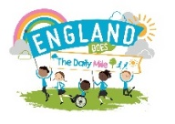On Friday 30th April, the whole school joined ‘England does the Daily Mile’ day, a national event. Each class went out across the school day and ran/walked/staggered a mile!

**Italian Lunch Wednesday 26th May**

On Wednesday 26th May, children can enjoy Fun Food Wednesday. The kitchen will be serving an array of food originating from Italy (Cost is £2.05). Please book your child’s lunch on SchoolComms before Wednesday 19th May.



**Dinner money**

As of 12th April, all dinner money and bookings for lunch moved over to the Schoolcomms system. Could I please remind all parents that you **must** book your child’s lunch even if you don’t pay for it. If you have any questions about our Schoolcomms platform, please don’t hesitate to contact Caroline, who will be more than happy to help.

**National Online Safety Remote Education Accreditation**

I am delighted to confirm that we have successfully met all the criteria to achieve the National Online Safety Remote Education Accreditation for the 2020/21 academic year.



**10 Mile Heroes**

At Durham Lane Primary, we have some incredibly, thoughtful and inspirational children. We would like to share how proud we are of one of students called Isla.

Isla has joined the '10 mile hero' challenge for Zoe's Place Children's Hospice.

Isla saw the advert and wanted to learn more about it. She read a story about Baby Ted and was moved to hear about the babies and children who have life threatening illnesses so she wanted to do something to help.

Isla must cycle a minimum of 10 miles during the month of May. She has already said she is going to 'smash it' (her words) as she wants to really help the charity.

Isla's mum and dad will be helping her to log her rides during the month and hopefully she will be able to 'smash' the challenge of 10 miles, but also 'smash' her fundraising target.

If you would like to support Isla with this challenge, she has her own fundraising page:

[https://zoesplace.enthuse.com/pf/gemma-rochester](https://zoesplace.enthuse.com/pf/gemma-rochester?fbclid=IwAR10EWMjoV8uB7bwJJNJhcSJhuh77101I2syqzLFhmBUV7TOK3RT-hCMwGE)

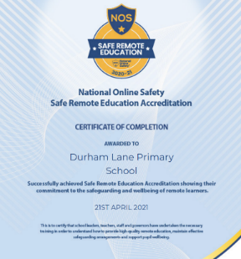

**Parental engagement/online survey**

Thank you to all those parents who completed our Sex Relationships and Education online survey.

From September 2021, all primary age children must be taught Relationships and Health Education to support them in growing up to be healthy, happy, safe and able to manage the challenges and opportunities of modern life.

We have welcomed all of your views and appreciate your thoughts and support with this curriculum offer.

**Covid-19 testing**

If your child/family member is waiting for a Covid-19 test result, could you please email me the result, even if it is over the weekend. My email address is [helen.gregory@sbcschools.org.uk](mailto:helen.gregory@sbcschools.org.uk)

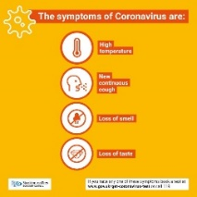This will help me plan and inform Public Health England. If your child is currently living with a household member or sibling who is waiting for a test result, once that result has been confirmed, please let me know, in accordance with the up to date guidelines which can be found on the school website.

**Thank you**

Finally, I would just like to take this opportunity to thank everyone who supports our school.

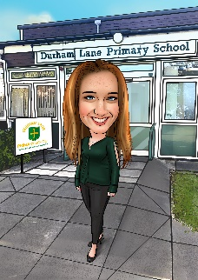

Kind regards,

Mrs H Gregory

[helen.gregory@sbcschools.org.uk](mailto:helen.gregory@sbcschools.org.uk)