Head Teacher – Mrs Helen Gregory
Amberley Way, Eaglescliffe
Stockton on Tees
TS16 0NG
Tel: 01642 780742

Email: durhamlane@sbcschools.org.uk
Website: www.durhamlane.org.uk

Dear Parents and Carers,
I hope you have all had a restful summer and your children are as excited as we all are about coming back to school. I would like to take this opportunity to update you on some important changes that you need to be aware of.
I sincerely hope that, during this up and coming year, school will return to some sense of normality after a very difficult two years and I would therefore like to inform you about the latest Covid-19 guidance.
COVID-19 guidance

It is no longer recommended that children should be kept in consistent groups (‘bubbles’). This means that bubbles will not need to be used in schools from the autumn term and that whole school assemblies can resume as well as the children all being able to now mix at playtimes and lunchtimes. However, there is still the possibility that it may become necessary to reintroduce ‘bubbles’ for a temporary period, to reduce mixing between groups, should there be a rise in Covid-19 cases in school. We are extremely happy that our children can now once again be seated in groups (rather than in rows) and that they are now able to share equipment. For this reason, please may we request that your child does not bring in a pencil case, as all equipment will be provided.

New guidance states that only children who test positive for Covid-19 must self-isolate for 10 days. Children who have been in contact with a person who has tested positive, do not need to self-isolate unless they begin to display symptoms, whereby they must take a PCR test. However, to ensure we continue to keep our school community safe, we request that if a member of your family household tests positive for Covid-19, that you inform the school office as soon as possible and that, should your child display any Covid-19 symptoms, you keep them at home and seek out a PCR test immediately.

Should there be an outbreak of Covid-19 in school (i.e. 5 or more positive cases in a 10 day period), we will be consulting with Public Heath England and we will inform you of their advice.

We will continue to ensure that we are vigilant about hand washing, cleaning and ventilation to reduce the risk of transmission of Covid-19. Although face masks are no longer a legal requirement and we do not expect parents to wear them on the playground, we would politely ask that, if you need to come into the school building for any reason (such as dropping off/collecting your child in the Nursery conservatory, visiting the school office, having a meeting in school), that you wear a face mask.

Dropping off and collecting
Please may we remind you that we will continue with the classroom doors being open at 8.45am. However, the school gates will now close at 8.55am.
Collection times are as follows:
- Nursery 30 hour provision – 3pm
- Reception - 3.15pm
- Year 1 and Year 2 – 3.15pm
- Year 3, Year 4, Year 5 and Year 6 – 3.20pm
After school clubs
During the summer holidays, Mrs Kate Gehrmann, who has worked in our school for 8 years, made the difficult decision to resign from her after school club post. She will be very much missed as she has been a hard-working and dedicated member of the school team who always cared deeply for the children and often went above and beyond to help school staff; we wish her all the best for the future.
After school club will continue under the management of Mrs Caroline Ennion, supported by Mrs Lyndsey Sampson and Mrs Susan I’Anson, who we are delighted to welcome on board later in September. As a result, some clubs will not be operating until her arrival. Further information, with regards to all after school clubs, will be sent out shortly.
School lunches
If you wish your child to have a school lunch, this must be booked on Schoolcomms/School Gateway App. This includes children who are in receipt of free school meals or receive universal free school meals (Reception, Year 1 and Year 2 children).
Home learning
In accordance with government guidelines, all children must complete home learning each week. Home learning activities will continue to be set in most cases via the Seesaw app and will vary according to your child’s age. If you have any problems accessing Seesaw, please contact your child’s class teacher.
Thanks
During the summer holidays, there has been a variety of contractors working in our school which now looks amazing. I would personally like to thank Mrs Donna Betham for arranging a team of staff from Johnston Matthee to voluntarily paint the interior of the school building. This was a massive amount of work and we are extremely grateful for all their hard work.
I would also like to thank all the school staff, in particular Mr James McMillan, who have worked tirelessly throughout the school holidays to ensure the school building and the classrooms look incredible and are ready for the next academic year. Thanks also go out to Mrs Clair Robinson our Chair of Governors for locking and onlocking the building so that the contractors could access the site.
I am looking forward to seeing all the children’s smiling faces on September the 6th and am sure that the new academic year will be a rewarding and fun experience for all the children and staff.

Yours Sincerely
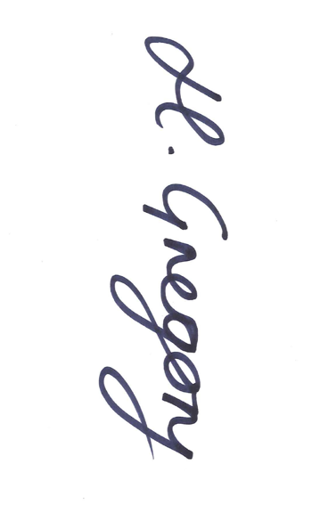
Helen Gregory

