Newsletter
7th October 2021
Dear Parents and Carers,
As we approach the end of this half term, I would personally like to thank each and every one of you for supporting our small community school. The children impress me every day with their work ethic, attitude towards their learning and impeccable manners.

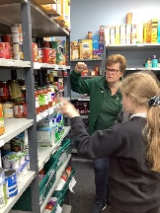
Parent Consultation evenings
Staff will be hosting Zoom parent consultations on Tuesday 2nd and 9th November whereby teachers will be offering a 10 minute consultation appointment. On Monday 11th October, a booking form will be placed under the canopy on the large playground for you to book a parent consultation zoom meeting. Due to Covid-19, please could you use your own pen when booking in a time slot?

School Photos
Tempest will be visiting school on Wednesday 13th October.
Children will be able to have individual photographs plus any siblings who are school that day.
Due to Covid-19 restrictions, we will unfortunately not be able to invite younger siblings in for group photos.
We thank you for your understanding.

Flu Vaccination
The NHS immunisation team will be in school on Thursday 14th October. A letter with details went out last week; please scan in your QR code to consent for the vaccination.

Food bank
Thank you so much for supporting our School Harvest Festival this year. 35 boxes of food, donated for the Harvest Festival, were delivered to the Foodbank in Billingham. Some Year 6 children helped to sort and check the food and packed some food boxes for families in need. They learned about where the food was donated from, why people need to use a foodbank and how the food is distributed. Thanks again for all of the donations, to Mrs Guest for organising the Harvest Festival in school and to Mrs Leigh for helping with transport.

Christmas Fundraising Project
We are once again offering you the opportunity to purchase items made from your child’s artwork. Items available include Christmas cards, mugs, coasters, notepads, wrapping paper with gift tags and thank you cards. More detailed information will be shared via the Schoolcomms app.

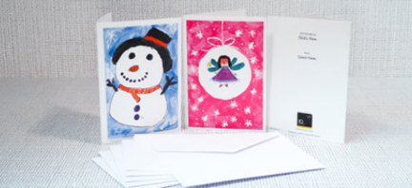

PTA
We are looking to start up a Friends of Durham Lane group, or what might be more commonly known as a Parent Teacher Association. This is a great way of building relations between the school and families, and, at the same time, making a real contribution to the quality of the school life for all. We sent out a parental questionnaire to gauge how well the group would be received and how much support it would get. From the survey, it was clear that this was something the school community would really benefit from. We are proposing that anyone who would like to be part of the PTA, could meet on Monday 1st November at 3.30pm. Tea, coffee and cakes will be served!

If you would like to attend the meeting, please could you email helen.gregory@sbcschools.org.uk Please note, there will also be free child care should you require it. Please just come round to the school office and we can check everyone in from there!
If you cannot attend the meeting, but are still interested in joining the PTA, could you please also email me?

Christmas Theatre visits
We are delighted to inform you that we have organised visits for KS1 and KS2 children to go to see a theatrical performance over the Christmas period.
The Tin Foil Astronaut
The children in Year 1 and Year 2 have been invited to see the ‘Tin Foil Astronaut’ at the Arc in Stockton on Friday 10th December 2021.

Elf
The children in KS2 will be visiting Stockton Riverside College to watch ‘Elf’. This will be one of the first school trips that we have been able to offer the children for quite some time and we are very much looking forward to it!
Years 3 and 4 will be attending on Monday December 6th and Years 5 and 6 will be attending on Tuesday December 7th.
More details will be sent out in the coming weeks with regards to both of these events.

Christmas Calendar We are currently at the planning stage for more events during the month of December. More details of exciting events will be announced soon!

After School Club – From 1st November

Monday – Cookery (Year 3 – Year 6)

Tuesday – Active Kicks Football (Year 4 – Year 6)

Wednesday – Dance Fuzion (Year 1 – Year 6)
Art Club (Reception – Year 6)

Thursday – Multi sports (Year 3 – Year 6)
Sewing Club (Year 2- Year 6)

Friday – Newspaper and Reporting (Year 3 – Year 6)
All bookings will go live on the week beginning the 18th October.

PD days
- 8th November
- 6th June
- 21st July

Cake Sale
On Wednesday 20th October, Angie, our school cook, has offered, as a treat, to make some cakes for the children to purchase. Each cake will be 50p and children can buy more than one for other family members. However, only one cake can be eaten during the school day (that includes the teachers too!!).

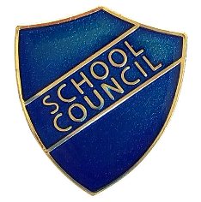
School Council
On Wednesday 29th September, we had a visit from Stuart Levine from Stockton Borough Council’s Democratic Services who delivered a fantastic assembly about the importance of having a voice in the democratic process. The children thoroughly enjoyed the assembly and even The Queen (AKA Miss Barrett) put in an appearance. Since the assembly, the children have been busy creating manifestos and using a real polling booth to vote for their School Councillors who have now been introduced to the whole school. The children have also been given a School Council badge competition form and we welcome all entries.

Thank you
Any questions or queries you may have, please don’t hesitate to speak to me on the playground, email me on the address below or call the school office for an appointment.

Kind regards,

Mrs H Gregory

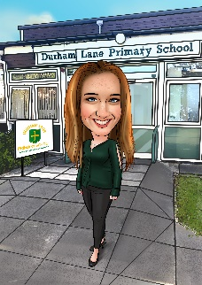
helen.gregory@sbcschools.org.uk

