Newsletter 26th October 2023
Dear Parents and Carers,
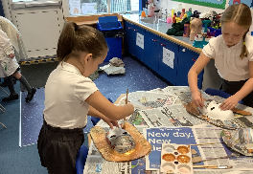
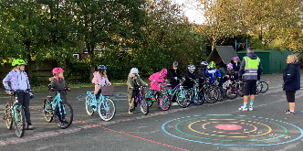
As we approach the end of another very busy half term, with Spooky Discos, a Harvest Festival, Stem Club, Bikeability, Swimming, Nurse Ambassador training, visits to our local area, parents’ evenings, visits to museums, visitors from a whole host of people, we can safely say that this has been possibly the busiest half term we have ever had! And, although this term has been extremely busy, I would like to say that your children have been an absolute delight; they truly make our job incredibly easy and very rewarding.
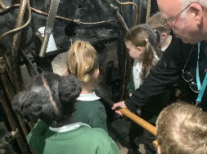
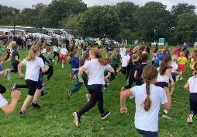

Key dates
- Break up for October half term on Friday 27th October – return on Monday 6th November
- 23rd October – 27th October then, after half term, 6th November – 10th November Swimming every afternoon for Y4 (more details to follow) please note there will be no swimming on Monday 6th November
- 6th November – Y3 and Y4 rescheduled Egyptian Day
- 9th November – Y6 visit to the remembrance garden and Drake Book shop
- 10th November Y6 Class assembly on Remembrance – more details to follow
- 14th November KS1 Sports Festival AM – Y2
- 17th November – Children in Need Day
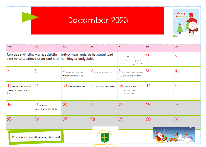
The December Christmas Calendar has been attached separately.
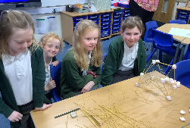
Jewellery, nail varnish, makeup and hair styles
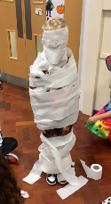
We have had a number of children who have recently had their ears pierced. Unfortunately, due to our Health and Safety Policy, children are unable to participate in PE lessons whilst wearing earrings. If children are unable to complete their PE lessons (2 hours a week is statutory), they will be educated in another year group/classroom and will need to complete work related to their core academic skills.
We would really recommend that if your child wishes to have their ears pierced, they do this over the summer holidays.
Also, can I please remind parents that children should not be wearing nail varnish or make up in school and, as part of our school policy, extreme hairstyles are not permitted at school. This includes extremely short cuts, coloured hair dye and tram lines /etchings cut into the hair. Long hair should be tied back whenever possible.
School Uniform

Over the last half term, I have noticed some children not adhering to our school uniform policy. I have attached our school uniform policy which has been taken from our School Prospectus –found on the School Website.

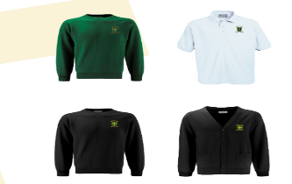
We have a school uniform that is worn by children from Nursery to Year 6. Our children are proud to belong to the school community and value the identity that the uniform provides. The uniform is intended to be smart, practical and economical and adds to the sense of family and belonging we have in our school. We expect all children to be neat and tidy and to take pride in their appearance.
Our uniform consists of:
• Green jumpers, or cardigans either plain or
embroidered with the school logo; (Y6 black);
• Grey skirt/pinafore/trousers (not tight leggings)/shorts; (Y6 black);
• White polo shirt/white blouse, plain or with school logo on;
• School fleeces embroidered with the school logo are available for outdoor use;
• Flat, black sensible shoes (preferably with Velcro fastenings for younger children). We currently allow black trainers. Coloured trainers and open
toed/heeled sandals are NOT allowed;
• Green gingham summer dresses or grey shorts may be worn during the
summer term/first part of autumn term.
Year 6 pupils are encouraged to wear a special black sweatshirt and blackskirts/trousers to show that they are the most responsible and oldest pupils in the school.
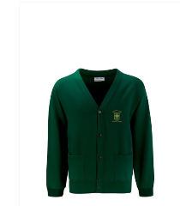
Key items of school uniform such as; book bags and PE bags are available to order from the main school office or our uniform suppliers Motif8. The supplier offers a service embroidering children’s initials onto uniform for a small extra charge.
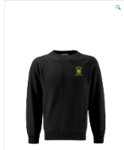

P.E. Uniform
Children will need a change of clothing for P.E. activities.
These should be kept in a drawstring bag in school and taken home regularly to be washed.
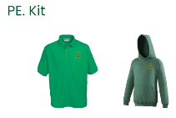
The kit includes:
• plain black shorts;
• white or green T-Shirt;
• Plain black tracksuit;
• plimsolls or a change of trainers.
• Items of PE clothing, including T-shirts and tracksuits, may also be ordered
from the school suppliers. Children who are involved in after-school sporting activities should bring in a separate kit for their activity including additional footwear.
Amberley Way Park
We have been informed of a few incidents which have occurred prior to the start of the day at Amberley Play Park. We are requesting that children who walk to school alone (predominately the Year 5 and Year 6 children), do not access the park before school as these incidents are sometimes hindering a smooth start to the school day as the children are coming into their classrooms feeling agitated after squabbles they have had in the park! They are also arriving with muddy footwear and uniforms.
Food Hampers
I have been contacted by some local charities who would like to know if we have any families in the school community who would like some food hampers. If you are needing any assistance, please do not hesitate to contact me privately on helen.gregory@durhamlane.org.uk
This information will be kept extremely confidential and I may be able to access additional support for you and your family.

Children in Need - Friday 17th November
This year, the School Council have decided that they would like our school to participate in this event by rainbow colours! This means the children can wear brightly coloured clothes of any colour!

Each child will be asked to donate £1 or more towards the non-uniform day.
The School Council have also organised the following:
A raffle for a teddy bear. Children will pay 20p per ticket/£1 a strip and these can be purchased before school (under the gazebo) or during the school day starting on Monday November 13th. School councillors will visit the classes to sell the tickets.
Pudsey Bear drawing/colouring competition- this will take place during the morning of November 17th in school. There will be no charge for this competition and members of the School Council will decide on a winning picture from each class. Prizes will be awarded on the day. The children want the theme of the pictures to be ‘Pudsey doing his favourite hobby’.
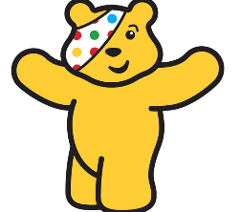
Bake sale- this will take place in the school hall after school on Friday November 17th. We would be really grateful for any donations of cakes/biscuits, either homemade or shop bought (please be aware of our no nut policy). These should be sent in to school via your child’s class teacher either on Thursday 16th November or Friday 17th November.

Thank you

Kind regards,
H Gregory

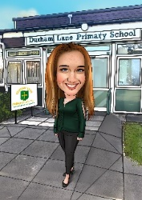
helen.gregory@durhamlane.org.uk

