Newsletter
15th December 2023
Dear Parents and Carers,
As we approach the end of such a busy term, it has been lovely to reflect on all of the wonderful moments from the past four months. From our Remembrance assembly, our Christmas performances, movie night and sleep over, the incredible learning opportunities and experiences our children have had, the sporting events the children have attended and excelled in, to our now yearly Christmas ‘Live raffle’ (which never fails to entertain!) - it has been a truly amazing term!
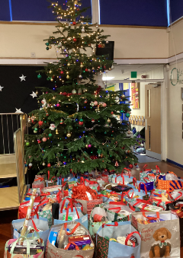
It has also been wonderful to see lots of charitable events taking place within school this term. We were able to raise an incredible £769.72 for Children in Need. More recently, we have been completely overwhelmed with your generosity for our Cause for Christmas Hamper campaign. These hampers support families across Teesside in genuine financial hardship. This will make a real difference at Christmas for many families in need!

Christmas Fundraising
We would like to say a great big thank you to everybody who has helped to raise money for our fundraising project (buying resources for the KS1/KS2 playground, as requested by the children) during the festive season. Whether you have donated prizes and purchased tickets for our Christmas Raffle, took part in the movie night/Santa sleepover, visited the Christmas fayre or attended our Oakwood performance, your generosity has been outstanding. To date, we have raised a massive £4,520 towards our project; this will go some way towards the £13,000 estimated amount of money we need to spend on the playground.

Christmas Performances
Thank you so much to each and every one of you for coming to support our children with their Christmas performances. Our children did an incredible job and I think you will all agree that their shows were wonderful. A huge thanks again to our wonderful staff team for supporting our children to put on such amazing Christmas performances.

Key dates
- 3rd January 2024 return to school
- 16th February break up for half term
- 26th February return to school
- 28th March break up for Easter holidays
- 15th April return to school
- 15th June – Summer Fayre
- PD days 3rd June and 22nd/23rd July 2024
After school activity clubs after the Christmas Holiday
Monday : Multi sports with Mr Roberts
3.30pm – 4.25pm (Y1 – Y2)
4.30pm – 5.25pm (Y3- Y6)
Tuesday:
- Relax Kids Y1-Y6 with Mrs Thomson
Wednesday
- Dance with Mrs Barnes Y1-Y6
Thursday
- Sports with Mr Sheahan Y1- Y3
Friday
- Boys Y5 and Y6 football with Middlesbrough Football Foundation
Thank you
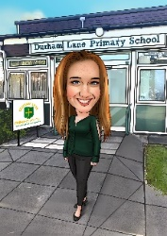
Over the Christmas holidays, I would like to remind everyone to stay safe, but most of all, to have fun with loved ones and enjoy this time of the year. I wish you all a very Merry Christmas and I am looking forward to seeing you all in the New Year.
Kind regards,
H Gregory

helen.gregory@durhamlane.org.uk

