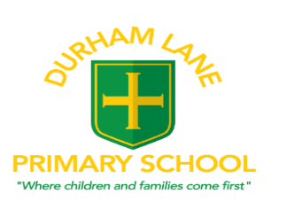

Nursery 30 hour request application form – for free childcare provision for
families who have an eligibility code. (The first 15 hours are AM Nursery Mon-Fri). If you only require AM nursery 15 hours you do not need to complete this form.

Please state your unique eligibility code …………………………………………………….

Child’s details
Child’s Surname:
Child’s First and Middle Names:
Child’s Date of Birth: | .. /.. /…. | Current age | Gender Male/Female
Child’s Home address:  (this must be the child’s normal place of residence and not a relative or carer’s address) | Postcode

Parents/ Guardians/Carer’s Details
Title: | Title:
Surname: | Surname:
First Name: | First Name:
Relationship to Child: | Relationship to Child:
Address: (if different from that of the child given above) | Address: (if different from that of the child given above)
National Insurance Number | National Insurance Number
Please send this form back into school or email it to caroline.ennion@durhamlane.org.uk

Please note that once you have submitted this form you cannot change the number of hours or sessions requested until we send you the next form for January 2024.

