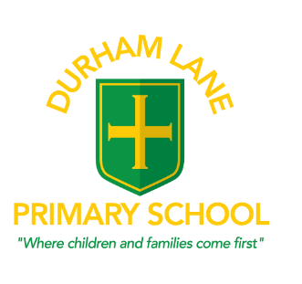
Head Teacher – Mrs Helen Gregory
Amberley Way, Eaglescliffe
Stockton on Tees
TS16 0NG
Tel: 01642 780742

Email: admin@durhamlane.org.uk
Website: www.durhamlane.org.uk

Online Free School Meals

We have bought into an online system where you (or, if you give permission, the school) can check if you are eligible for Free School Meals. The system will then continue to re-check on a regular basis, so hopefully you should never need to re-apply again (unless there is a large gap).

We would like to ask as many of you as possible to find out if you could claim on the Online Free School Meal for your child. This would greatly help the school and your child, as every child who qualifies secures the extra £1,300 to be used by school to provide the additional services that support your children. Please either:

- Apply online yourself at https://www.cloudforedu.org.uk/ofsm/sims/
- or fill in the declaration attached to this letter so that we can apply on your behalf

All you need to complete an application are your contact details, National Insurance Number, date of birth and the name and date of birth of children attending school. It is very easy, and every parent who successfully claims for a Free School Meal helps to improve the quality and breadth of the services we can provide the whole Durham Lane Primary School community.

Do not worry about accidentally making a ‘false claim’ – your child will either qualify or not qualify for the additional funding and it will not affect any other claims for benefits or tax relief that you apply for.

If you need any more information, please do not hesitate to contact school.

Thank you,

Kind regards,

Mrs Gregory

Declaration for school to apply on your behalf

Eligibility is based on one of the following benefits :
- Universal Credit (provided you have an annual net earned income of no more than £7,400, as assessed by earnings from up to three of your most recent assessment periods)
- Income Support
- Income-based Jobseeker's Allowance
- Income-related Employment and Support Allowance
- Support under Part VI of the Immigration and Asylum Act 1999
- The guarantee element of Pension Credit
- Child Tax Credit (provided you're not also entitled to Working Tax Credit and have an annual gross income of no more than £16,190)
- Working Tax Credit run-on - paid for four weeks after you stop qualifying for Working Tax Credit

I agree that you will use the information provided to process my claim for free school meals and will contact other sources as allowed by law to verify my initial, and ongoing, entitlement.
I agree that the information may be used to ensure accuracy of records across the local authority and the check against fraud.
I agree that you can inform the school(s) attended by my child of their initial and ongoing entitlement to free school meals.
You may be aware of our Privacy Policy (https://www.cloudforedu.org.uk/ofsm/sims/pages/privacy_policy)
To complete an application on your behalf, we need you to provide:
Child’s name …………………………………………………. Class ………………………..

Additional information required:
Home Address and Post Code …………………………………………………………….…………………………………………………………………………………………………...

- Parent name …………………………………. ……….. Date of birth ……………………..

National Insurance number……………………………………….

- Parent name……………………………………………. Date of birth………………………..

National Insurance number………………………………………..

Signed……………………………………………………….. Date ……………………………….
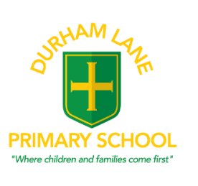
Information for you regarding Free School Meals and the reason we ask you to apply
This Pupil Premium funding is essential to help us to provide your children with the highest level of support we can give them and, along with our existing school budget, has helped to pay for:
- Subsidies to attend residential trips
- Subsidies for school trips and associated transport costs
- Subsidies to support afterschool activities
- Specialist small group support for children across school who work with some of our Teaching Assistants. This effectively reduces the class sizes for many Literacy and Numeracy lessons for all children.
- Booster groups for Y6 and Y2 children
- Additional teaching sessions for children across school
- Specialist reading support

This is a substantial pot of money which is helping us to support all children, as they are jointly funded by the school budget and the Pupil Premium money.
Our school does not automatically receive this funding – to receive it we have to encourage all of our parents who are receiving certain benefits to apply for a free school meal for their child.
As well your child receiving their free school meal, the school will be given additional funding of £1,300 for each pupil who qualifies. Service children (e.g. children with parents in the Army, Navy or RAF) also attract additional funding at a lower level to provide support when required. Without this additional funding, almost all academic support and extra services that we provide to children and families would not be possible.

From September 2014 the Government decided to offer a universal free school meal to all 5-7 year olds (Reception – Year 2). Whilst we think that this is an excellent initiative, it does unfortunately mean that many parents in Key Stage 1 feel that there is little point in making a claim for a free school meal. However, if your child is eligible for a free school meal and you make a claim, the school would receive approximately £1,300 each year to provide additional support for your child. This extra £1,300 will continue to be paid to support your child’s education for six years after the original claim, even if your circumstances change and you are no longer receiving benefits.
It is important for all parents who are in receipt of benefits to apply for Free School Meals and make it possible for this additional funding to be used to support your child and others in our school.

Please make sure you apply for Free School Meals even if your child prefers a packed lunch or are in Key Stage 1 and receive their Universal Free Meal, as we still get the money to help to improve our services across the full school.
Last year, a local school who is only 4 miles away received approximately £100,000 of additional Pupil Premium funding to support the children in their school that is an incredible amount of additional funding which can go straight back into supporting the children at Durham Lane Primary School.

