* Locomotion
* Treasure Island

**Lunch**

All Key Stage One children are entitled to a free school meal, irrespective of household income. If your child is having a school lunch, you will need to book this on SchoolComms before the school day starts. If your child is having a packed lunch, you do not need to notify school.

**Uniform**

Please can you make sure all your child’s uniform, shoes and coats are clearly labelled with their name.

**End of school day**

Year 1 children are collected at 3.15pm outside the Year 1 classroom. If your child is being collected by somebody who does not usually pick them up, please can you let the class teacher know on the morning or phone the school office.

**Home Learning**

Weekly home learning tasks will be set on a Friday. It needs to be completed and submitted by the following Thursday. Activities will be closely linked to your child’s learning in class that week. If you need help accessing any activities, please speak to your child’s class teacher. If you ever have any concerns, please feel free to contact your child’s teacher. It is vital that Year 1 children are heard read as often as possible to aid their reading development.

**Welcome to Year 1**

Your child’s class teacher is **Miss Hugill** and **Mrs Spruce** isyour child’s teaching assistants.

**Topics**

In Year One this year, some of the topics that will be studied are:

* The House Jack Built
* Florence and Mary
* Noah’s Ark

**What your child needs each day**

Your child will be receiving reading books whenever they need to change them. Try to encourage your child to remind us if they need to change their book, as they will be encouraged to do this themselves. They will also be given a Little Wandle reading book every Wednesday, which they will have read in class. This should be returned the next week Please record how they have read on Boom Reader.

It is recommended that children have their PE kit* in school every day. This is because PE days can sometimes change due to weather and other circumstances in school. PE is an important part of the curriculum and we want to encourage all children to enjoy and join in with PE sessions.

*\*PE kit consists of: school’s green polo shirt or plain white t-shirt, blue/black shorts or jogging bottoms and plimsolls/trainers. Jewellery, watches and metal hairclips must be removed before lessons. Please make sure your child is not wearing earrings on PE days.*

Please make sure your child brings in a water bottle so they can have a drink throughout the day.

**Snack**

Key Stage One children are part of the Government free fruit scheme and a piece of free fruit will be made available to them at morning break. If your child would like to bring their own snack, they can bring their own piece of fruit or veg to eat at morning playtime. Just a reminder to make sure small fruit such as grapes and tomatoes are cut in half to prevent choking.

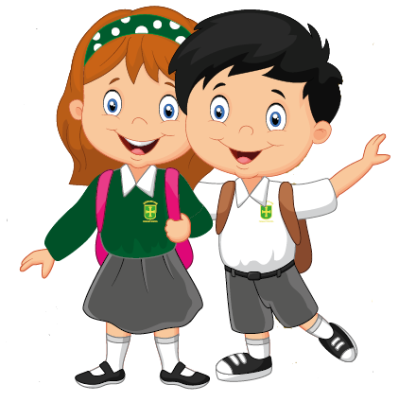

**Year 1**

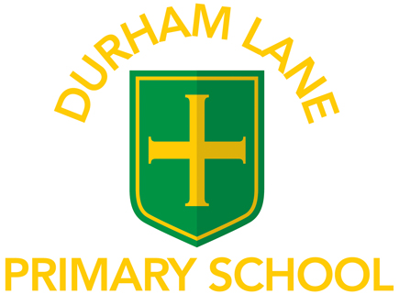

# **Welcome to**

A Guide for Parents

2022/2023

**Reading**

Reading is a key focus in Key Stage 1. Your child’s reading skills are developed through a combination of phonics lessons, weekly guided reading and independent reading. Your child has a set of reading books in their wallet to read at home over the course of a week. It is extremely beneficial to listen to your child read as often as possible. Question your child about what they have read to check their understanding.

**Any problems or concerns**

If you have any problems or concerns, we operate an ‘open door’ policy so please do not hesitate to ask if you would like to talk to your child’s class teacher.

Your child’s class teacher is always your first point of contact. If you are dissatisfied, the first person to contact is Miss Barrett, the Deputy Head Teacher. The next person to contact is Mrs Gregory, our Head Teacher.

We hope to solve problems promptly and with care and are always happy to discuss your concerns.

We appreciate your continued support.

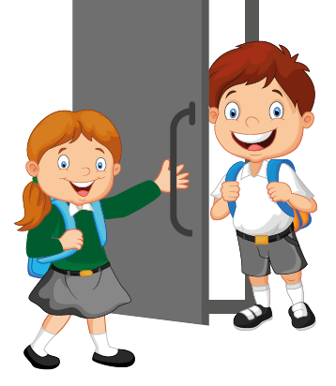

Key Stage One