* Treasure Island
* Florence and Edith

**Snack**

Key Stage One children are part of the Government free fruit scheme and a piece of free fruit will be made available to them at morning break. If your child would like to bring their own snack, they can bring their own piece of fruit or veg to eat at morning playtime. Just a reminder to make sure small fruit such as grapes and tomatoes are cut in half to prevent choking.

**Lunch**

All Key Stage One children are entitled to a free school meal, irrespective of household income. If your child is having a school lunch, you will need to book this on School Comms before the school day starts. If your child is having a packed lunch, you do not need to notify school.

**Uniform**

Please can you make sure all your child’s uniform, shoes, PE Kits and coats are clearly labelled with their name.

**End of school day**

Year 2 children are collected at 3.15pm outside the Year 2 classroom. If your child is being collected by somebody who does not usually pick them up, please can you let the class teacher know on the morning or phone the school office.

**Home Learning & Spellings**

Your child will be given a yellow spelling book. Every Thursday, your child needs to bring in their yellow spelling book. They will be tested on their spellings on Fridays and new spellings will be given out on Fridays. Help your child to practise their weekly spellings using the ‘Look, Say, Cover, Write, Check’ Method:

‘*Look at the word, say the word, cover it up, write the word, check the word’*

Your child will be given a home learning folder. Weekly home learning will be sent home every Friday. Please complete and submit this by the following Friday. Activities will be closely linked to your child’s learning in class that week. If you need help accessing any activities, or have any concerns please speak to your child’s class teacher.

**Welcome to Year 2**

Your child’s class teacher is **Mrs Neave**. Miss **McBurney** supports particular pupils within your child’s class but may work with your child from time to time. We are also lucky to have the support of **Miss Bissell** this year. A student teacher who will be working with and supporting your child’s learning throughout the year.

**Topics**

In Year Two this year, some of the topics that will be studied are:

* George Stephenson
* The House That Jack Built
* Noah’s Arc

**What your child needs each day**

Your child will bring home a colour banded reading book. Your child has the opportunity to change their book as much as necessary. In Year Two we encourage children to take ownership of their reading and support them to ask to change their book once they have completed their current book. We will support with this as much as possible as we understand many children will need help with this in the first term. **Please send your child’s** **reading book to school every day**. We ask you to support your child with their reading by reading with your child **3 times per week** as minimum. Please record when your child has read at home on Boom Reader. Your support with this is greatly appreciated!

It is recommended that children have their PE kit* in school every day. This is because PE days can sometimes change due to weather and other circumstances in school. PE is an important part of the curriculum and we want to encourage all children to enjoy and join in with PE sessions.

*\*PE kit consists of: school’s green polo shirt or plain white t-shirt, blue/black shorts or jogging bottoms and plimsolls/trainers. Jewellery, watches and metal hairclips must be removed before lessons. Please make sure your child is not wearing earrings on PE days.*

Please make sure your child brings in a water bottle so they can have a drink throughout the day.

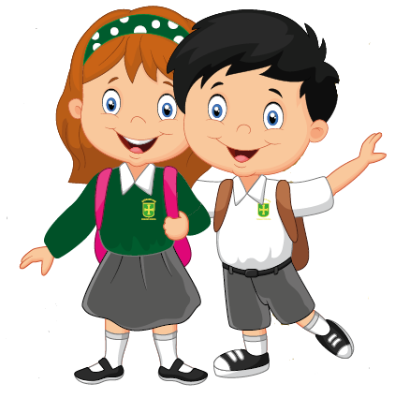

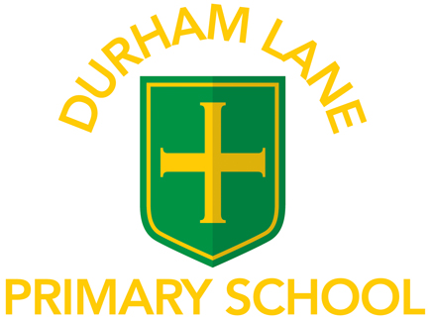

# Welcome to

A Guide for Parents

2023/2024

**Reading**

Reading is a key focus in Key Stage 1. Your child’s reading skills are developed through a combination of phonics lessons, weekly guided reading sessions, whole class read and respond lessons and independent reading opportunities. It is extremely beneficial to listen to your child read as often as possible. Question your child about what they have read to check their understanding and clarify new vocabulary. We encourage children to read and share a wide range of books. If your child wishes to read books from home we would love to hear them share their thoughts and opinions about them in class.

**Any problems or concerns**

If you have any problems or concerns, we operate an ‘open door’ policy so please do not hesitate to ask if you would like to talk to your child’s class teacher.

Your child’s class teacher is always your first point of contact. If you are dissatisfied, the first person to contact is Miss Barrett, the Deputy Head teacher. The next person to contact is Mrs Gregory, our Head Teacher.

We hope to solve problems promptly and with care and are always happy to discuss your concerns.

We appreciate your continued support.

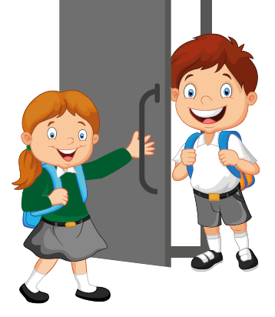

Year 2

Key Stage One