* Endangered Animals
* Romans
* Plants

**Lunch**

All children in KS2 are required to pay for their school lunch, unless they qualify for Free School Meals. A school lunch costs £2.50 per day (£12.50 a week). Lunch booking takes place on School Comms. Please see Mrs Ennion if you are unsure of how to do this.   
  
**Uniform**

Please can you make sure all your child’s uniform, shoes and coats are clearly labelled with their name. Please remind children that it is their responsibility to look after their uniform.

**End of school day**

Year 3 children are collected at 3.20pm on the playground. If your child is being collected by somebody who does not usually pick them up, please can you let the class teacher know on the morning or phone the school office.

**Homework, Spellings & Maths Practice**

Every Thursday, your child needs to bring in their green spelling and green Maths Practice books. They will be tested on their spellings and Maths Practice on Thursday and new ones will be given out on Friday. Help your child to practise their weekly spellings using the ‘Look, Say, Cover, Write, Check’ Method and encourage children to practise their Maths Practice task at home. Children will always be given an example Maths Practice question so they know they style they will be asked. More information will be provided about Maths Practice in the following weeks as this is something different to KS1.

Your child’s homework will be handed out weekly on a Friday on Seesaw or on paper in their blue homework wallet and needs to be back in the following Thursday. Help your child with their homework if needed. Please don’t do it for them, but ask questions about it to ensure understanding. If you ever have any concerns, please feel free to contact your child’s teacher.

**Welcome to Year 3**

Your child’s class teacher is **Miss Drew. Mrs Afsar** and **Mrs Serrecchia** will be in class supporting particular pupils within our class, but may work with your child from time to time.

**Topics**

In Year Three this year, some of the topics that will be studied are:

* The Ancient Egyptians
* Sounds of Christmas
* George’s Marvellous Medicine

**What your child needs each day**

Children will be able to change their reading books whenever they need to this year. It will be **their responsibility** to change their own book whenever needed. Please ensure that you are logging their reading on Boom Reader as we will be monitoring children who are not reading at home regularly.

|  |  |
| --- | --- |
| Monday | Reading book, PE kit* |
| Tuesday | Reading book |
| Wednesday | Reading book |
| Thursday | Spelling and green maths practice books, homework, Reading book, PE kit* |
| Friday | Reading book |

*\** P.E Kit consists of: black shorts or track-suit bottoms, white t-shirt or green Durham Lane shirt, socks and trainers. All jewellery, watches and metal hair-clips must be removed before P.E. lessons for the safety of the children. Please make sure your child has warm clothes for outdoor PE as the weather becomes colder.

**Please note that PE days may change each half term in order to share teaching time with the specialist PE coaches. Please ensure your child has a PE kit in school every day.**

Please make sure your child brings in a water bottle so they can have a drink throughout the day.

**School Bags**

We need to keep our corridors as uncluttered as possible so please do not send backpacks and large bags to school. Your child can bring a small bag, such as a Durham Lane book bag to school every day. If you do not have one of these, we sell them for £4. Please see Mrs Ennion in the office for more information.   
**Snack**

Children in KS2 are not entitled to a daily snack. If your child would like to bring their own snack, they can bring their own piece of fruit or veg to eat at morning playtime. Just a reminder to make sure small fruit such as grapes and tomatoes are cut in half to prevent choking.

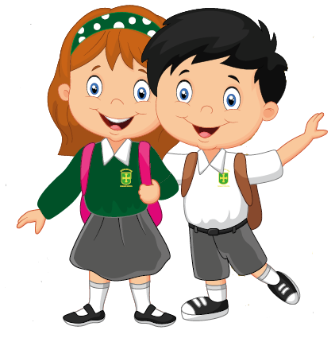

**Reading**

Reading skills will continue to be developed throughout KS2. Your child’s reading skills are developed through a combination of weekly guided reading and some independent reading. Your child has a reading book in their bag to read at home and it is now their responsibility to change their reading book when they have finished it. It is extremely beneficial to listen to your child read as often as possible. Question your child about what they have read to check their understanding. Please record their reading on Boom Reader so we know which books they have read. We will be completing a class reading chart at the end of each week with rewards given out for regular home reading.

**Any problems or concerns**

If you have any problems or concerns, we operate an ‘open door’ policy. Please do not hesitate to ask if you would like to talk to your child’s class teacher. We will be checking the children’s reading records at least once a week so please feel free to write a message in there. Your child’s class teacher is always your first point of contact. If you are dissatisfied, the first person to contact is Miss Barrett, the Deputy Head Teacher. The next person to contact is Mrs Gregory, our Head Teacher.

We hope to solve problems promptly and with care and are always happy to discuss your concerns.

We appreciate your continued support.

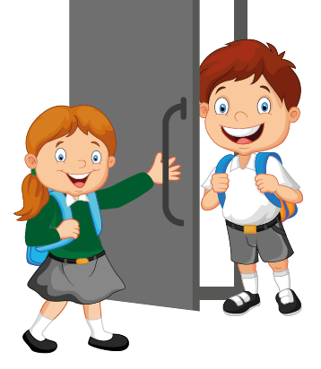



# Welcome to

A Guide for Parents

2023/24

Year 3

Key Stage Two