**Uniform**

Please can you make sure all your child’s uniform, shoes and coats are clearly labelled with their name. Please remind children that it is their responsibility to look after their uniform.

**End of school day**

Year 5 children are collected at 3.20pm at the classroom door. If your child is walking home, they need to complete a ‘walk home’ letter before they will be allowed to. A list of children who are walking home is kept in the classroom.

**Homework, Spellings & Maths Practice**

Every Thursday, your child needs to bring in their green spelling and green Maths Practice books. They will be tested on their spellings and Maths Practice on Thursday and new ones will be given out on Friday. Help your child to practise their weekly spellings using the ‘Look, Say, Cover, Write, Check’ Method and encourage children to practise their Maths Practice task at home. Children will always be given an example Maths Practice question so they know they style they will be asked.

Your child’s homework will be handed out weekly on a Fridays, and needs to be back in the following Thursday. Help your child with their homework if needed. Please don’t do it for them, but ask questions about it to ensure understanding. If you ever have any concerns, please feel free to contact your child’s teacher.

**Welcome to Year 5**

Your child’s class teacher is **Mrs Eastwood.** **Miss Harding** and **Miss** **Smith** will also be working in your child’s class.

In Year Five this year, some of the topics that will be studied are:

* Street Child (The Victorians.)
* Healthy Me
* The Greeks and modern-day Greece
* Natural Disasters
* The Mayans

**What your child needs each day**

Children will be able to change their reading books whenever they need to. It will be their responsibility to change their own book whenever needed. Please ensure that you are recording this on Boom reader when they have read.

Reading books and PE kits need to be in school every day. It is advisable to bring in a PE bag with a full PE kit, and leave this in school on your child’s peg.

*\** P.E Kit consists of: black shorts or track-suit bottoms, white t-shirt or green Durham Lane shirt, socks and trainers. All jewellery, watches and metal hair-clips must be removed before P.E. lessons for the safety of the children. Please make sure your child has warm clothes for outdoor PE as the weather becomes colder.   
**Please note that PE days may change each half term in order to share teaching time with the specialist PE coaches.**

**Autumn PE days: Wednesdays and Thursdays.**

Please make sure your child brings in a water bottle so they can have a drink throughout the day.

**School Bags**

We need to keep our corridors as uncluttered as possible so please do not send backpacks and large bags to school. Your child can bring a small bag, such as a Durham Lane book bag to school every day. If you do not have one of these, we sell them for £4. Please see Mrs Ennion in the office for more information.   
**Snack**

If your child would like to bring their own snack, they can bring their own piece of fruit or veg to eat at morning playtime. Just a reminder to make sure small fruit such as grapes and tomatoes are cut in half to prevent choking.

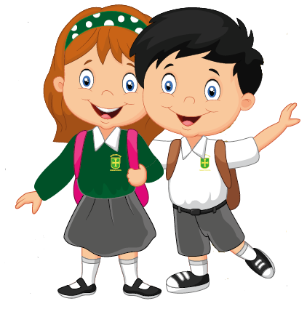

**Reading**

Reading skills will continue to be developed throughout KS2. Your child’s reading skills are developed through a combination of weekly guided reading and some independent reading. Your child has a reading book in their wallet to read at home and it is their responsibility to change their reading book when they have finished it. It is extremely beneficial to listen to your child read as often as possible. Question your child about what they have read to check their understanding. Please record all reading on Boom reader. Your child will be bringing home a Boom reader login and book mark on the first day.

**Any problems or concerns**

If you have any problems or concerns, we operate an ‘open door’ policy. Please do not hesitate to ask if you would like to talk to your child’s class teacher. We will be checking the children’s reading records at least once a week so please feel free to write a message in there. Your child’s class teacher is always your first point of contact. If you are dissatisfied, the first person to contact is Miss Barrett, the Deputy Head Teacher. The next person to contact is Mrs Gregory, our Head Teacher.

We hope to solve problems promptly and with care and are always happy to discuss your concerns.

We appreciate your continued support.

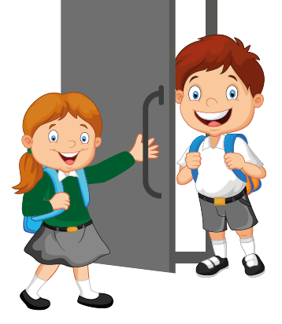



# Welcome to

A Guide for Parents

2023/2024

Year 5

Key Stage Two