**Other information**

* PE lessons will be on Mondays and Wednesdays for the first term, but please try and have kits in school every day as days will change after Christmas.
* Spellings will be given out on Fridays for a test the following Friday.
* Maths Practice will be given out on Fridays for a test the following Friday.
* Homework will be usually on Seesaw/in homework files every Friday and must be completed by Thursday at the latest to give the teacher time to mark it and return it by Friday. From time to time, your child will be asked to complete a research project to help with independent study. Further details will appear later in the year.
* SATs Week will be the week beginning 8th May 2023 and there will be a meeting in February to give you more details. We respectfully request that parents do not arrange holidays during this time. If you have any concerns about SATS, please do not hesitate to contact us.

**Any Problems or Concerns**

If you have any problems or concerns, we operate an ‘open door’ policy; please do not hesitate to come in and talk to us. Feel free to pop into school to arrange a mutually convenient time to talk with your child’s teacher.

We will endeavour to respond as soon as possible. Your child’s class teacher is always your first point of contact. If you want to put a comment in your child’s reading record book, we will happily respond (please tell your child to alert us to the fact that you have done so).

If you are dissatisfied with a response from your child’s teacher, because she is the Deputy Head Teacher, the next person to contact would be Mrs Gregory, our Head Teacher who will be happy to help you.

We hope to solve problems promptly and with care and are always happy to discuss your concerns.

### **About Year 6…**

Your child’s class teacher is Miss Barrett and Mrs Sampson also works in your child’s class. Mrs Williams will usually teach your child on Tuesday and Thursday afternoons to cover Miss Barrett’s Deputy Head release time.

**TOPICS**

In Year Six this year, the main topics that will be studied are:

* Earth and Space/Superheroes
* Skara Brae- from Bronze Age to Iron Age
* Rainforests/Kensuke’s Kingdom

**The Weekly Timetable – what is needed and when:**

**Monday –** Reading wallet with school reading book and record. PE kit

#### Tuesday – **Reading wallet with school reading book and record.**

**Wednesday –** Reading wallet with school reading book and record.

PE Kit

**Thursday –** Reading wallet with school reading book and record.

- Homework (some will continue to be done on Seesaw).

**Friday –** Reading wallet with school reading book and record.

- Green maths practice book and spelling book.

*It is a good idea for P.E kits to be available at all times during the week, just in case we have extra opportunities. P.E Kit consists of: black/navy shorts or track-suit bottoms, white/green Durham Lane t-shirt, socks and trainers. Jewellery, watches and metal hair-clips must be removed before P.E. lessons for the safety of the children.

**How parents can help:**

* Reading and discussing texts/books with your child as often as possible (helping them with our Year 6 reading challenge).
* Help your child to learn their weekly Maths Practice.
* Help your child to learn their weekly Spellings, using the ‘Look, Say, Cover, Write, Check’ Method:

*‘Write the word, look at it, say it, cover it up,*

*write it again, check if you’re correct’*

* Help with homework if needed. Don’t do it for them, but ask questions about it to ensure understanding.
* Make sure that all school clothing is labelled with their full name and class number.

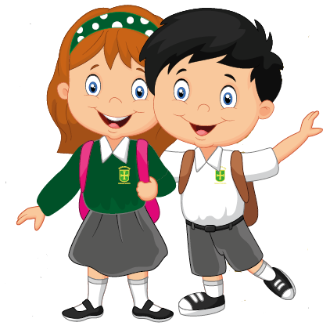

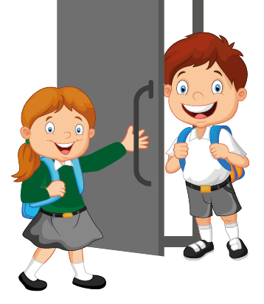

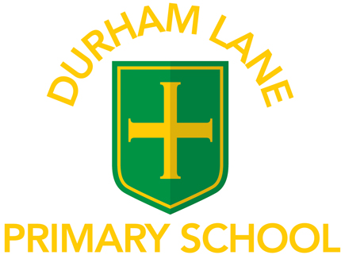

# Welcome to

A Guide for Parents

2023/24

Year 6

Key Stage Two