

**Newsletter** **7th November 2024**

**Dear Parents and Carers,**

As we are head towards the end of this Autumn Term, I would like to thank you again for your continued support.

We have a long lists of events planned this half term (please see key dates). This, in my opinion, is the best time of year to work in education. The fun, excitement, anticipation, children’s performances, all add to working in what I believe is the best job in the world and I am truly grateful for being the Head Teacher of such a wonderful community school.

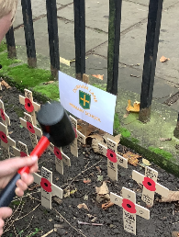**Key Events**

**Year 6 Remembrance**

Year 6 visited the Remembrance Garden in Stockton, where they planted their own poppy crosses, visited the cenotaph and asked the veterans some questions. They then visited Drake‘s Bookshop to share books.

**Year 4 and Year 4 Viking workshop**

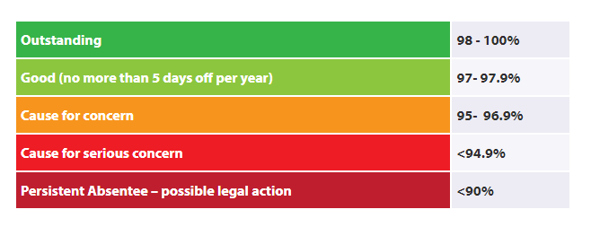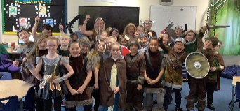Year 3 and 4 have had a fabulous day this week with Rob, completing their Viking workshop! They played Viking games, completed some archaeological digging and practised battle skills!

[](https://www.facebook.com/photo/?fbid=986783300163185&set=pcb.986788293496019&__cft__%5b0%5d=AZVbtV-mY8AsFBbRCOSvhkyc6p7edsSSYIw1uq2Ag0aBEXUKyLSq3tGWKrckFPUpLK6Kyx-t9GM6kEoDymogMGqYuMIS_GwwqElPm9AHjWYltwvAwO3O2gDf8vn8lpEwwUJ3ct2DbJtAj3CKzW9dV56ljuxlA42f1NLiS7tqZMG9ApU_8Vtdjx8EDPbMufAUGPc&__tn__=*bH-R)**Princess Trust**

Emily has raised £541, plus has donated her hair to the Princess Trust!

What an inspiration!

**Attendance**

As stated in my last newsletter, I shared the importance of regular attendance. I can now share that this academic year so far, the overall attendance for Durham Lane Primary is currently at 96.9%. However, this does equate to **249 days of lost learning** so far this academic year with **72 of these days** being holidays. This percentage is a slight improvement from this time last year, which was 95.2%, so I thank you for your continued support with improving attendance.

**Definitions of attendance and Persistent Absenteeism**

We expect outstanding attendance for all. However, we do recognise that there are times when students will be absent from school. If your child’s attendance drops below 90%, for this Autumn Term; we will be contacting parents by letter towards the end of December 2024. Your child’s attendance will then be closely monitored upon review. If we are still concerned, you may be asked to attend a meeting in school called an Attendance Panel.

**Key dates**

* 15th November – Children in Need- children to dress in PJs or onesies (more details on email previously sent)
* 18th November – Y1/Y2 Great Fire of London Workshops
* 29th November – Non-uniform day for Christmas Fair donations (more details to follow)
* 29th November – Santa Sleep over and movie night
* 2nd December – Christmas Fayre 2pm -4.30pm
* 6th December – Mayor’s Christmas Carol Concert – Choir to attend (more details to follow)
* 9th December – Oakwood Christmas Performance Y1- Y6
* 11th December – Early Years Christmas Performance
* 12th December – Christmas Lunch and Jumper day
* 16th December – AM Early Years Christmas Party
* 17th December – PM Y1/Y2 Christmas Party
* 18th December AM- Y3/Y4 Christmas Party
* 18th December PM – Y5/Y6 Christmas Party
* 19th December – Panto day in school
* 20th December – Break up for Christmas holidays
* 7th January – Return to school

****Thank you for your support!

Kind regards,

H Gregory