 **Newsletter April 2025**

**Dear Parents and Carers,**

I can’t quite believe how quickly this year is going! I would like to thank the staff for organising so many lovely activities, visits and enrichment activities for the children this term and next; I am very grateful to have such a dedicated and hard-working staff team.

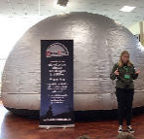**Science Week**

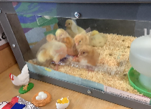A huge, huge thanks to Mrs Guest for planning such a fantastic array of activities during Science week. The purpose of Science week was to excite and enthuse our children about STEM and to help them see how they could have a career in this industry in the future. Mrs Guest has been extremely busy working behind the scenes to apply for our school to achieve The Quality Mark in Science (watch this space!).

 **Mobile Phones**

Can we please remind parents that our school has a strict ‘No Mobile Phones in School’ rule as can be seen in our E-safety/Acceptable use policy which states:

***Pupils’ use of personal devices: If a pupil brings a mobile device to school then the phone or device will be confiscated and will be held in a secure place in the school office. Mobile phones and devices will be released to parents/carers at the end of the school day’.*** This includes all mobile phone and smart watches which have text messaging capacity.

**Packed lunches**

From 1st April there are legislative changes with regards to disposing food waste and recyling within schools. As part of this, we would like to remind parents that any child on packed lunches will need to take their food waste and recycling home every day. We recommend you place a plastic bag in the packed lunch box so uneaten items can be kept in there.

**Key dates**

* 11th April break up for Easter holidays
* 28th April return to school
* 28th April group photographs
* 30th April Dr Tim Physics workshop year 5 and 6
* 5th May bank holiday
* 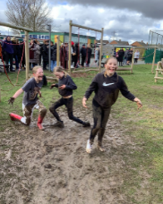12th May – 15th May Y6 SATs
* 23rd May break up for half term
* 2nd June and 21st July - PD days
* 3rd June return to school after half term
* 11th June Nursery and Reception visit to Roarsome
* 16th June Y1- Y6 Ninja warrior visit
* 16th June Health/Sports Week
* 25th - 27th June Y6 Staycation
* 3rd July meet your new teacher morning
* 7th July Sports Day Y1- Y6 1.30pm – 3pm
* 8th July Sports Day Early Years AM
* 14th July ‘Reserve’ Sports Day Y1- Y6 1.30pm -3pm
* 15th July ‘Reserve’ Sports Day Early Years AM
* 18th July Y6 leavers assembly 2pm
* 18th July Break up for the Summer holidays
* 1st September PDday
* 2nd September return to schoo**l**

**Please note additional information with regards to some of these events will be sent out in due course.**



**Parent Questionnaire Findings**

Thank you to everyone who completed the parental questionnaire. I really do appreciate your feedback. After the holidays, I will email you with actions with regards to some of yours and the children’s suggestions.

**Mud Run and Easter Raffle fundraising**

A big well done to all our children who took part in our Mud Run and to all of you who have donated prizes for our Easter raffle! We have managed to raise over £3,000 for the Mud Run plus over £800 from the Easter Raffle. The children have been discussing what they would like to spend the money on, which is for a quiet area under a canopy on the KS2 playground with some new games and equipment for playtime. The children have been very active and have already made lots of suggestions which we have been able to implement immediately, which are:

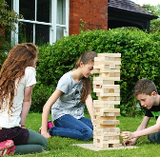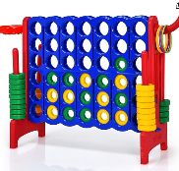*Connect 4

*Quoits

*Footballs

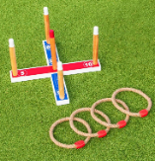*Jenga

*Building stepping stones

*Large team games

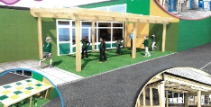The canopy order has been placed and will be installed over the May half term.

**Staffing changes**

We would like to say thank you and good luck to Mr Roberts who will be leaving Durham Lane this week. Good luck in your new role. We are happy to announce that we have managed to replace Mr Roberts with a coach from Simon Carson’s coaching company who will be able to support our PE curriculum and also work with the children every lunch time.

**Easter/Easter Egg Decorating Competition:**

The children had a wonderful time decorating eggs and creating some eggcellent models! Some of the parents have also sent in some amazing eggamples which made it very difficult for Mr. McNeill to choose winners!

We would also like to say a big thank you to Nicola Ferguson from Tees Valley Community Church, for her interesting Easter assembly which the children absolutely loved.

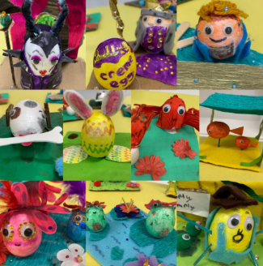

**After school clubs after Easter Holidays**

**Monday**:

* Football with coach from Simon Carson 3.30pm – 4.30pm Y1- Y2
* Football with Simon Carson 4.30pm – 5.30pm Y3-Y6

**Tuesday**:

* Relax Kids Y1-Y6

**Wednesday**

* Dance R-Y6

**Thursday**

* Multi sports with Mr Sheahan Y3- Y6

**Friday**

**Thank you**

Kind regards,

H Gregory

****[helen.gregory@durhamlane.org.uk](mailto:helen.gregory@durhamlane.org.uk)