

 **Newsletter**

**10th January 2025**

**Dear Parents and Carers,**

Happy New Year and I hope you all had a wonderful relaxing Christmas holidays.

I would like to personally thank you for all of your kind messages and well wishes before Christmas. I feel much better and I have now returned back to work full-time.

**SEN**

As you aware Mrs Neave, our SENDCo had a baby boy in October and is currently on maternity leave. If you need to discuss any concerns with regards to your child having any Special Educational Needs, please contact me whilst Mrs Neave is on maternity leave and I will be more than happy to help.

**Key dates**

* Y3 swimming 17th – 21st Feb
* 21st February break up for half term
* 3rd March return to school
* Y3 swimming 3rd March – 7th March
* 4th March – 7th March Book Fair in school
* 17th March and 24th March Parents’ Evenings – (more details will be shared soon)
* 11th April break up for Easter holidays
* 28th April return to school
* PD day 2nd June and 21st July 2025
* 14th June Summer Fayre

**After school clubs this half term**

**Monday:**

* Football with Mr Roberts 3.30pm – 4.25pm (Y1 and Y2)
* Football with Mr Roberts 4.30pm – 5.25pm (Y3, Y4, Y5 and Y6)

**Tuesday**:

* Relax Kids Y1-Y6 with Mrs Thomson

**Wednesday**

* Dance R-Y6 with Mrs Barnes

**Thursday**

* Multi-sports with Mr Sheahan Y3- Y6

Usual before and after school clubs can still be booked on our School Comms app.



**Earrings**

Children are able to wear small, stud earrings during the school day. However, they are not permitted to wear them during PE lessons. Children must either be able to remove them themselves or not wear them on the day of their PE lesson. Unfortunately, due to health and safety reasons, we are not permitted to remove them or put tape on them. We thank you for your understanding**.**

**Packed Lunches**

If your child brings a packed lunch to school, please note that we have several children in school who have severe nut allergies and request that parents do not include nuts or any nut-based products in packed lunches. Children must also bring their own drink (not fizzy) and a spoon for yoghurt or jelly. Staff based in the dining hall will monitor children who bring packed lunches and will encourage them to eat all items provided (please only add to a lunchbox the food you expect your child to eat).

**Website/Facebook**

We have spent a lot of time updating our website. There is whole host of information on the site such as:

* Year group information
* Curriculum
* Policies
* Letters home
* Our vision, value and ethos

If you haven’t had chance to have a look at our new website, please go to: [www.durhamlane.org.uk](http://www.durhamlane.org.uk)

Also, we like to regularly share what is going on in school so we share this by updating our community Facebook page. This page is used to inform you of all the daily exciting learning activities that are happening during the school day.

You can find us by searching on Facebook.

Durham Lane Primary Community Facebook page.

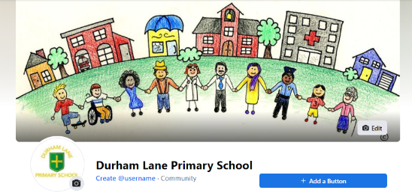



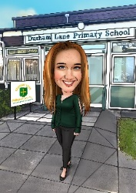**Thank you**

Kind regards,

H Gregory

[helen.gregory@durhamlane.org.uk](mailto:helen.gregory@durhamlane.org.uk)