**Newsletter 16th May 2025**

**Dear Parents and Carers,**

I can’t quite believe how quickly this year is going! I would like to thank the staff for organising so many lovely activities, visits and enrichment activities for the children this term and next.

**Key dates**

* 20th May – Y4 class assembly
* 23rd May - Break up for half term
* 2nd June - PD day (children to return to school on 3rd June)
* 19th May and 3rd June (for 2 weeks)- Y5 swimming
* 5th June- a second hand book sale with proceeds going to MIND
* 6th June- non-uniform day for summer fayre
* 14th June - Summer Fayre 1pm- 4pm
* 16th June – Healthy Sports week
* 16th June – Y1- Y6 visit to Ninja Warrior
* 19th June – Early Help Coffee morning
* 25th – 27th  June - Year 6 ‘Staycation’
* 3rd July – class swap (meet your new teacher) morning
* 7th July - Yr1- Yr6 Sports day 1.30pm 3.15pm (reserve day, if the weather is poor, 14th July 1.30pm- 3.15pm)
* 8th July - Early Years’ sports day 9.10am (reserve day, if weather is poor, 15th July 9.10am)
* 8th July – SATs result day (please note we do not share results until the end of year when reports are sent out.
* 11th July- Reports to be sent home
* 18th July – 2pm Y6 leavers’ assembly

**Summer Fayre**

Tickets for our Summer Fayre go on sale on 23rd May via School Gateway app. The summer fayre will be a lovely chance for us all to spend time together; this event is usually a very small profit event which will help to pay for our Christmas fun events for the children.

We will have a large selection of stalls, inflatables, live music from Tom Powell, plus lots more. All you need to bring is your camping chair, picnic and drinks!

On 6th June, we are having a ‘non-uniform’ day and, in return, could we please ask for some donations for either a child’s/adult’s tombola (plus any teddy bears for our teddy bear tombola).

Note: Tombola items to be in school on Friday 6th June. Our after school club will be making some cakes for the event. However, if you would like to send in cake donations, could you send them in on Friday 13th June.

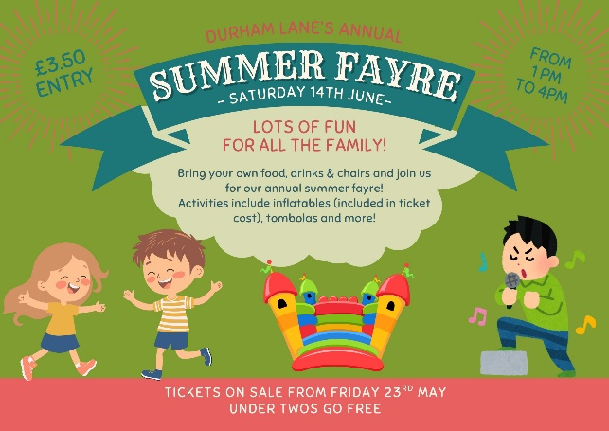



We are very excited about this event and we are really hoping you can all make it. Also, this year, we are opening the event up to local residents and past/future pupils and families. However, please note this event is **not** suitable for pets and all children under the age of 16 will need to be accompanied by an adult. If you do have anytime to support us with this event either prior (Friday 13th June) or during the day, please let Caroline Ennion or Leanne Bain know in the school office as we would be most grateful for your help.

More details to follow.



**Year 6**

We would like to say a great big well done to all of the children in Year 6 for all the effort and hard-work that they have put in to prepare themselves for their SATs. The children are focusing hard and can begin to look forward to their ‘Staycation’ and other fun activities. Thank you to one of our parents who kindly gave us a donation towards some treats for our Y6 children for all of their hard work.



**Stockton Wheelers**

On Wednesday 7th May we welcomed Mr Newton from Stockton Wheelers Cycling Club to our assembly. He came to talk about his Limitless inclusivity cycling sessions.

Limitless is an inclusive cycling session held at Middlesbrough Sports Village for riders with different disabilities. The riders are aged from 4 to 76!

There are bikes for visually impaired riders, tandems, tricycles, hand cycles, and recumbents. Everybody who wants to have a cycle is supported by volunteers who run the session with Mr Newton.

Sessions run on specific Saturdays from 1:00 to 3:00 pm at Middlesbrough Sports Village. They are free to riders, but a donation for track hire is welcomed. Sessions are advertised on social media. If you know someone who like to come along for the ride, or if you’d like to volunteer, email Mr Newton at [Limitless@stocktonwheelers.org.uk](mailto:Limitless@stocktonwheelers.org.uk), or speak to Mrs Bashford...

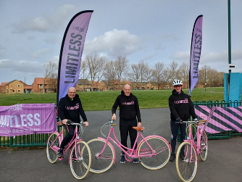



**Second hand book sale**

On June 5th, at 3:20pm, Sophie, one of our wonderful School Councillors, alongside her mum, has organised a second hand book sale with all proceeds going to the charity, MIND. The children will be receiving an assembly (from one of the MIND team) on June 4th where they will learn about the fantastic work this charity does. If you have any spare second hand books which are in good condition, please bring them to school before Wednesday June 4th.



**VE Day Celebrations**

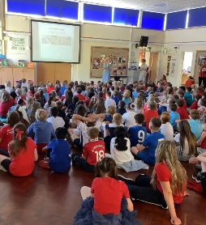As you will be aware, on Friday we celebrated the 80th anniversary of VE day and what a day we had in school! I would just like to thank Mrs Wheatley who organised the day. I think you will all agree that the outside area looked fantastic and the children performed beautifully whilst we raised the Union Jack Flag.

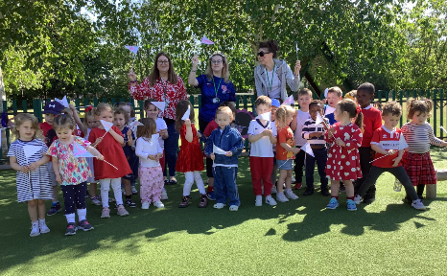

**Thank you**

Kind regards,

H Gregory

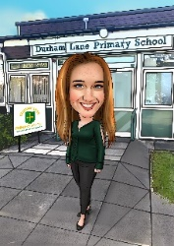[helen.gregory@durhamlane.org.uk](mailto:helen.gregory@durhamlane.org.uk)