

**Newsletter** **11th October 2024**

**Dear Parents and Carers,**

As we are half way through this half term, I would personally like to thank each and every one of you for supporting our small community school. The children impress me every day with their work ethic, attitude towards their learning and impeccable manners.

**Attendance**

**Our Vision**

We strive to meet 100% targets for attendance and punctuality, but why are attendance and punctuality so important?

Missing out on lessons leaves children vulnerable to falling behind. We seek to ensure that all our students receive a full-time education which maximises opportunities for each student to realise their true potential, both socially and academically.

Over a period of five school years, a student with 90% attendance will have missed half of a whole year of schooling. Similarly, students with poor punctuality, miss valuable lesson time and, if it happens regularly, progress will be jeopardised.

**Definitions of attendance**

The table sets out our definitions of attendance. We expect outstanding attendance for all. However, we do recognise that there are times when students will be absent from school. If attendance drops below 97%, we will be contacting parents immediately to put a plan in place to make improvements.

Should you wish to know your child's current school attendance, please do not hesitate to contact Mrs Gregory. Also, if your child is poorly and will not be attending school, you MUST call the school office every day before 9.30am (emails will not be accepted). If you do not call the school office, we will be treating your child as missing from education and may need to contact the Local Authority.

We appreciate some medical appointments need to be attended during the school day. We require evidence of these appointments. Please note, these appointments do affect your child’s overall attendance percentage and will be taken into account if your child drops below 97%.

We thought we would share these interesting graphics with you - good school attendance and punctuality really does matter to improve children's life chances as they get older.

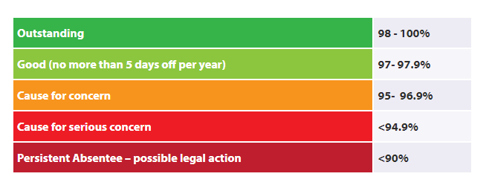

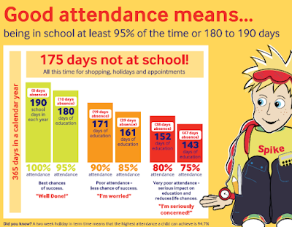

**Key dates**

* 14th October – NSPCC Assembly
* 14th and 21st October – Parents’ consultation evenings
* 18th October – Introduction to music tuition for children in KS2 TVMS
* 18th October Monster and Mayhem Disco 4.15pm – 5.15pm for Rec, Y1 and Yr2
* 18th October Monster and Mayhem Disco 5.30pm – 6.30pm Y3, Y4, Y5 and Y6 – Tickets on sale now
* Break up for October half term on Friday 25th October – return on Monday 4th November
* 23rd October Y2, Y5 and Y6 NSPCC workshops
* 4th November –Y3/Y4 Viking Workshop
* 5th November – 15th November October –Swimming every afternoon for Y4 (more details to follow) please note there will be no swimming on Monday 4th November
* 8th November Y6 Class assembly on Remembrance – more details to follow
* 18th November – Y1/Y2 Great Fire of London Workshops

**Jewellery and nail varnish**

We have had a number of children who have recently had their ears pierced. Unfortunately, due to our Health and Safety Policy, children are unable to complete PE whilst wearing earrings. If children are unable to complete their PE lessons (2 hours a week is statutory), they will be educated in another year group/classroom and will need to complete work related to their core academic skills.

We would really recommend that if your child has their ears pierced, they should remove them the evening before their PE lesson as school staff are not permitted to remove them.

Also, can I please remind parents that children should not be wearing nail varnish or make up in school.



**School Council**

On Wednesday 25th September, we had a visit from Stuart Levine from Stockton Borough Council’s Democratic Services who delivered a fantastic assembly about the importance of having a voice in the democratic process. Since the assembly, the children have been busy creating manifestos and using a real polling booth to vote for their School Councillors. Our new school councillors will be chosen by Monday 14th October.

We will soon be holding a competition to design the School Council badge and more details will follow.



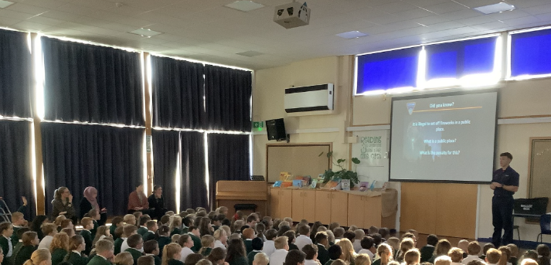

**Harvest Festival**

A huge thank you to all our families who donated to our Harvest Festival. Our donations weighed an amazing 350.50kg!

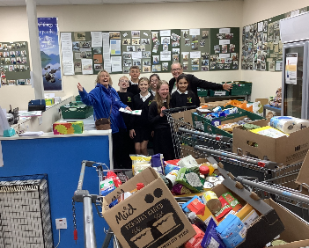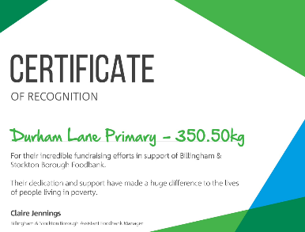

**Bonfire Night Safety**

A huge thank you to [Cleveland Fire Brigade UK](https://www.facebook.com/ClevelandFB?__cft__%5b0%5d=AZXn0X7gdFk0y-TsIpC8gOnwUXn1eYowRYUwLpdUYFFMgQpKXljOMpaQ77ldOYqTDN8Y6JM6-n-WUOyVEcFpOLP6s7Vwmvk2IjO6KNmPA6kWkqZJzEMmH0vXydGvjI7D8yRGizWhrIQi-r53Ik7Ww2v1Il_Fd3n7JsyyXS8gFqcWt4dOwJJs5kMogvETtUJK2zw&__tn__=-%5dK-R) who came to visit us to tell us how to keep safe around fireworks on Bonfire Night. We all also got a turn of squirting the fire hose!

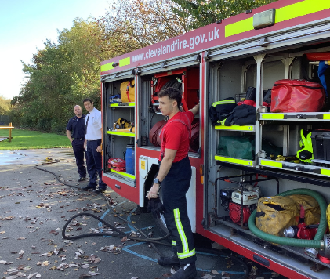

**The Little Princess Trust**

Emily, one of our Year Two pupils, has wanted to donate her hair for a number of years now and this year is the year this is happening.

The Little Princess Trust provides real hair wigs, free of charge, to children and young people who have lost their own hair through cancer treatment or to other conditions such as Alopecia.

This charity is also one of the largest funders of childhood cancer research in the UK.

“The Little Princess Trust relies solely on the generosity of its wonderful supporters who help the charity give Hair and Hope to so many children and young people with cancer each year."

If you would like to support Emily in her quest to raise funds, donating through JustGiving is simple, fast and totally secure. Once you donate, they'll send your money directly to Little Princess Trust, so it's the most efficient way to give - saving time and cutting costs for the charity.

You can donate to Emily’s JustGiving page by clicking here:

<https://www.justgiving.com/.../emily-balmer-1726758180547...>

JustGiving sends your donation straight to Little Princess Trust and automatically reclaims Gift Aid if you are a UK taxpayer, so your donation is worth even more.

Thank you for your support!

Thank you

Kind regards,

H Gregory

[helen.gregory@durhamlane.org.uk](mailto:helen.gregory@durhamlane.org.uk)